 | Document Number: |  |  |  | AAA/BBB/CCC/0000
 | Document Title: |  |  |  | Highways Agency HLD WP199 MMLite Circee and IAMS
 | Document Type: |  |  |  | High Level Design
2 |  | 27.02.12 |  | Second Submission of Circee HLD to Fluor and HA |  | MA
1 |  | 08.02.12 |  | First Submission of CIRCEE HLD to Fluor and HA |  | MA
REV |  | DATE | PAGE QTY | DESCRIPTION |  | AUTH | SPONS | GeneSYS | HA Consent
REVISION |  |  |  |  |  | APPROVALS |  | ACCEPTED

FUTURE PLANNED REVISIONS

Planned Amendment | Reason for Amendment | Planned date for next revision

Brief Description of Document:

This document presents the high level design for the OSS solution in support of the MMLite IAMS deployment.

Date Initiated: |  | Due date to CDCG for Lead Review: | [Ask Fluor sponsor for due date]

Record of Internal Revision

Revision | Date | Name | Review Comments | Project Control Check
0.1 | 31Jan 2012 | Mike Aslan | First Draft
0.2 | 08 Feb 2012 | Mike Aslan | Internally Reviewed
0.3 | 08 Feb 2012 | Mike Aslan | Internally Reviewed
0.4 | 13 Feb 2012 | MikeAslan | Circe HLD that went out to Fluor
0.5 | 21 Feb 2012 | Mike Aslan | First draft of IAMS HLD
0.6 | 24 Feb 2012 | Mike Aslan | Internally Reviewed

CONTENTS
CONTENTS 4
LIST OF FIGURES 7
LIST OF TABLES 8
ABBREVIATIONS 9
OBJECTIVES 10
1 Introduction 12
1.1 Purpose & Scope 12
1.2 Project Roles and Responsibilities 14
1.3 Background and Business Drivers 14
1.4 Links and references 15
1.5 Problem or Vision Statement 16
2 Service Impacts 19
2.1 Service type ST8RDH 19
2.2 Service type ST10CA1 21
2.3 Service type ST10CA2 22
2.3.1 Non-resilient Configurations 22
2.3.2 Resilient Configurations 22
2.4 Service Type ST10Cof1 23
2.5 Service Type ST10Cof2 25
2.5.1 Non-resilient Configurations 25
2.5.2 Resilient Configurations 25
3 System Architecture 28
3.1 System Functional Architecture 28
3.1.1 Functional Architecture Diagram 28
3.1.2 Description of System 29
3.2 Subsystem Functional Architectures 30
3.2.1 Netcool Functional Changes 30
3.2.2 Circee Functional Changes 35
3.3 Data model 42
3.3.1 High Level Data Model 42
3.3.2 Data Ownership Principle 45
3.4 Use Cases 46
3.4.1 Inventory Management 46
3.4.2 Fault Management 63
3.5 Business Processes 69
3.6 Data Flow 69
3.7 Interfaces 69
3.7.1 External Interface Changes 69
3.7.2 Internal Interface Changes 69
4 Non-Functional Architecture 71
4.1 Capacity and Dimensioning 71
4.2 Migration 72
4.3 Availability 73
4.4 Back up and Restore 73
4.5 Data Storage 73
4.6 Security 73
4.7 Reliability 73
5 Impacted Functional Specification Documents 75
6 Requirements and Solution Traceability 77
6.1 Functional Requirements and Requirements Mapping 77
7 Alarm Lists 96
7.1 7210SAS-M Alarm Lists 96
7.2 7210SAS-D Alarm List 98
7.3 Telindus Solo Mpeg2 Encoder Alarm List 99

LIST OF FIGURES
Figure 1 - Managed Motorways Lite Schematic Diagram 17
Figure 2 - Service Type 8RDH Offered via SAS-D 19
Figure 3 - 8RDH Service provided via SAS-M 20
Figure 4 - Service Diagram for Service ST10CA1 21
Figure 5 - Service Diagram for Service ST10CA2 (non-resilient) 22
Figure 6 - Service Diagram for Service ST10CA2 (resilient) 23
Figure 7 - Service Diagram for Service ST10Cof1 24
Figure 8 - Service Diagram for Service ST10Cof2 (non-resilient) 25
Figure 9 - ST10Cof2 (resilient) 26
Figure 10 - Functional Architecture Diagram - Managed Motorways Lite IAMS 28
Figure 11 - Netcool Functional Changes 30
Figure 12 - Circee Component Design Changes 40
Figure 13 - High Level Data Model 42
Figure 14 - Data Repository Changes 44
Figure 15 - Data Ownership 45
Figure 16 - Inventory Management Use Case diagram 47
Figure 17 - Create Service Activity diagram 48
Figure 18: Populate Service Activity diagram (Pt1 of 2) 50
Figure 19 - Populate Service Activity diagram (Pt 2 of 2) 51
Figure 20 - Provision Service Activity diagram 54
Figure 21 - Activate Service Activity diagram 55
Figure 22 - Decommission Service Activity diagram 56
Figure 23 - Rectify Data Activity diagram 58
Figure 24 - Cancel Service Activity diagram 61
Figure 25 - Fault Management Use Case diagram 64
Figure 26: Record Alarm-Clearance Alarm Activity diagram (Pt 1 of 2) 65
Figure 27 - Record Alarm-Clearance Alarm Activity diagram (Pt 2 of 2) 66
Figure 28 - Investigate Alarm Activity diagram 68

LIST OF TABLES
Table 1 - Roles and Responsibilities 14
Table 2 - Background and Business Drivers 15
Table 3 - Circee Requirements Coverage 37
Table 4 - Catalogs and Templates 39
Table 5 - Server Sizing Guidelines 72
Table 6 - List of Impacted Functional Specification Documents 75

ABBREVIATIONS
APTR | All Purpose Trunk Roads
CEC | Combined Equipment Cabinet
CTU | Camera Termination Unit
DMS | Document Management System
HA | Highways Agency
HLD | High Level Design Document
IAMS | Interim Alarm Management Solution
NRTS | National Road Transport Systems
OSS | Operations Support System
PTZ | Pan, Tilt and Zoom
QDT | Quinton Data Team
RMD | Roadside Multiple Diversity
SCR | Service Credits Regime
SDP | Service Delivery Point
SoR | Schedule of Requirements
SPC | Service provision capability
SLT | Service Level Targets
SPC | Service Provision Capability
ST | Service Type
STI | Service Type Instance
WP | Work Package

OBJECTIVES
The purpose of this document is to provide the High Level Design for the Circee and IAMS (Interim Alarm Management Solution) phases of Work Package 199 for the Highways Agency project. The document details the delta OSS design changes needed in support of Managed Motorways Lite. It represents the design for phase 1 of the solution. Phase 2 will provide the full solution, including the remaining Netcool and Circee updates for basic alarm handling, and the solution for the Netcool parent/child correlation.
This document captures the ‘delta’ to the base service charge solution [1] and does not document the system as a whole. It will ultimately be used to update the registered Functional Specification documents and other assurance documents, as necessary.
This document describes the Managed Motorways Lite solution, in terms of changes to:
- Supported Services
- System Architecture (as a whole)
- Sub-system Architectures (functional) for Netcool and Circee
- Data Model for Netcool and Circee
- Use Cases and Business Processes
- Non-functionals, including Capacity Modelling and Migration
- Functional Requirements
Unchanged system elements are described to give background and context.
The detailed design of each Subsystem described in the HLD will be provided by a Low Level Design Part 1 (LLD Part 1), which will be subsequently included as a distinct section of this document, and a Low Level Design Part 2 (LLD Part 2), which will exist as a separate document. The LLD Part 1 will provide the logical detailed design, the LLD Part 2, the physical detailed design

SECTION 1: Introduction

Introduction

Purpose & Scope
Work Package 199 is to deliver an OSS Solution to provide management of Managed Motorways Lite solution into the HA/NRTS network. The OSS solution will provide functionality in line with the contractual requirements stipulated in the statement of requirements.
The scope of the project in its entirety is limited to the following OSS subsystems.
- Fault Management – Management of fault alarms coming from the Managed Motorways Lite active devices (7210SAS-M, 7210SAS-D and Telindus Solo Mpeg2 Encoders).
- Inventory – Modelling and management of Managed Motorways infrastructure and services including Active, Passive and Civil aspects..
- Maintenance – Modelling of Managed Motorways Lite devices in the maintenance solution
- Trouble Ticketing – Support for the new devices and service types to be introduced as a result of the Managed Motorways Lite deployment.
The delivery at phase 1 of the project will deliver the bulk of the Inventory (Circee) capability and a basic alarm handling solution (a.k.a Interim Alarm Management Solution (IAMS)) within Netcool. The scope of each of the Circee and Netcool delivery aspects is enumerated below:
Netcool Scope:
- Alarm field mapping & formatting (including Severity & Summary)
- Problem/resolution event identification and processing
- De-duplication
- Fixed lookup tables (i.e. lookups with permanent/static values)
- Calculation of affected STIs + outages
- Simple enrichment (e.g. external Asset data queries in Circee)
- Automatic trouble ticketing.
- This basic alarm handling solution will be applied to the subset of alarms that are service affecting and to those that are potentially resilience affecting.
- Customer view showing potentially resilience affecting alarms
Circee Scope:
- Delivery of equipment templates and catalogue items
- Delivery of service templates

Project Roles and Responsibilities
Table 1 describes the roles and responsibilities of the people (GeneSYS, HA and Interfacing Organisations) involved in this process.
Name | Role
Ritu Bugli | ALU Project Manager
Gavin Barlow | ALU Lead Solution Architect
Ross Capel | ALU Design Lead
Michael Aslan | ALU Solution Architect
Hunter Barr | ALU Lead Business Analyst
Stewart Menzies | Fluor OSS Manager
Stuart Turner | Fluor GeneSYS NOC Manager
David Bolton | Fluor GeneSYS Deputy NOC Manager
Table 1 - Roles and Responsibilities

Background and Business Drivers
Benefits | Realisation | Associated  Critical Success Factors
Service-level views of events from the Network provide an additional level of Fault Management than events alone (Element Manager information). | The raw events generated by the element managers are de-duplicated, cleared, and enriched with the business level information provided by Circee and impact correlations. | CSF001
Trouble Tickets will be automatically created and linked to the associated Service Type Instances reducing the amount of operational time spent creating and linking the required information hence reducing the amount of time to resolve. | Omnibus is connected to APM via a gateway, which is configured to allow the appropriate types of alarms to pass through and create trouble tickets. | CSF002
End-to-End Service and Device specific performance related information will be automatically collected and raised providing pre-emptive alerts to be created in the Fault Management system. | The monitoring provided by Proviso allows detection of various thresholds being reached, so that preventative measures can be taken before a fault occurs. | CSF003
This work package will deliver full traceability from Requirements (including coverage of Schedule of Requirements and SLT Requirements) through Design, Development & Test with regular Internal gates including all Internal stakeholders to ensure quality is maintained throughout the delivery lifecycle. During each of these stages the impact of the work is continuously assessed to ensure minimal impact to the existing OSS Solution. | Each relevant component of the OSS solution will be amended so that the new equipment can be managed by Fluor with minimal impact to their operational processes. | CSF004
Table 2 - Background and Business Drivers

Links and references
Reference | Document Name | DMS Document ID
 | GYSRGDSSP0001_R10 PS-DS036 NRTS System Architecture | GYS/RGD/SSP/0001
 | Managed Motorway Lite Variation Report - Revision 3 | GYS/HWA/LTR/0630
 | Outline Specification for WP199 - REV01.3.doc | n/a
 | GYSRGDSSP0104_R03.0 PS-DS036-200 OSS Global Data Model.doc | GYS/RGD/SSP/0104
 | GYSRGDPRP0008_R12 Fault Management (PS DS010).doc | GYS/RGD/PRP/0008
 | Infrastructure Scenarios defined for Work Package 199 | n/a
 | AlarmList defined for Work package 199 | n/a
 | Circee Asset Templates defined for Work package 199 | n/a
 | Create Service Use Case v0.2 | n/a
 | Populate Service Use Case v0.2 | n/a
 | Provision Service Use Case v0.2 | n/a
 | Activate Service Use Case v0.2 | n/a
 | Deactivate Service Use Case v0.2 | n/a
 | Rectify Data Use Case v0.2 | n/a
 | Cancel Service Use Case v0.2 | n/a
 | Circee Service Templates | n/a
 | Record Alarm-Clearance Alarm v0.1 | n/a
 | Investigate Alarm v0.1 | n/a
 | GYSRGDSSP0009_R21 PS-DS036-05 Functional Specification Circee.doc | GYS/RGD/SSP/0009

Problem or Vision Statement
The OSS capability is required to manage the introduction of the Managed Motorways Lite solution.
The key drivers for Managed Motorways Lite are reduced infrastructure costs, reduced Opex costs and a solution suitable for deployment in both fibre rich and fibre poor sections of the motorway.
The solution pushes IP closer to the edge, performing CCTV encoding at the roadside rather than in remote Transmission Station locations. It uses smaller transmission cabinets to support services with network devices (7210SAS-M and 7210SAS-D) and camera encoding devices (Telindus Solo MPEG2 Encoder) which are both environmentally hardened. For cost reasons, a hierarchical design has been elaborated, using 7210SAS-MX in primary cabinets (nominally every 4 cabinets). The remaining cabinets (secondary cabinets) are based on 7210SAS-D. This comprises the network change for MMLite; this document provides the design for the OSS changes needed in support of it.
Figure 1 - Managed Motorways Lite Schematic Diagram shows a schematic of the Managed Motorways Lite network infrastructure.
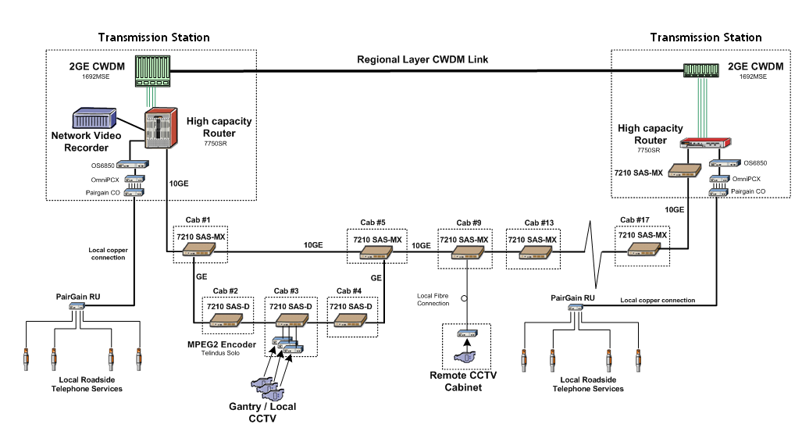
Figure 1 - Managed Motorways Lite Schematic Diagram

Section 2: Service Impacts

Service Impacts
The following are the services that will be supported by Managed Motorways Lite.

Service type ST8RDH
Service Category 8 refers to IP services. RDH stands for Road Diverse Hardened where:
  - Diverse --> Resilient
  - Hardened --> Environmentally hardened equipment.
Service type ST8RDH can be defined as an Ethernet Port Provision on a 7210SAS-M or a 7210SAS-D. Please note:
- Service is offered off 1 GE optical and electrical interfaces on SAS-M and SAS-D routers
- Includes IP traffic for PTZ cameras.
- SAS-D devices subtended off other SAS-D devices, cannot offer this service.
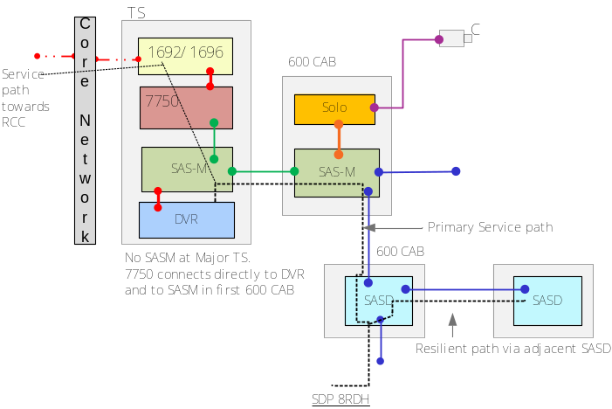
Figure 2 - Service Type 8RDH Offered via SAS-D

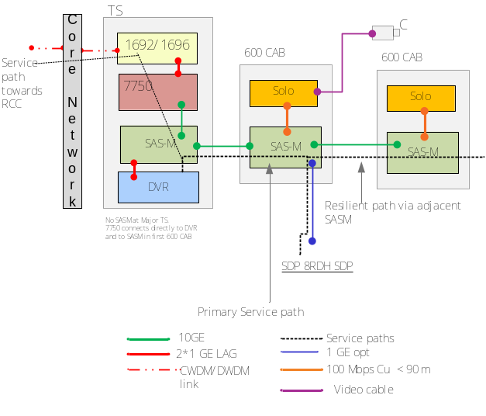
Figure 3 - 8RDH Service provided via SAS-M

The default SDP_Stream direction will be set in Circee as follows:
SDP8RDH-1: UP
SDP8RDH-2: DOWN.

Service type ST10CA1
Service Category 10 refers to CCTV Switched Video services.
- C --> stands for CODEC
- A --> stands for copper
- 1 --> Stands for single port.
For CCTV video supported by a copper cable infrastructure;
Provision of 1 Ethernet port variant copper based Solo Codec within the equipment cabinet. Please note:
- SDP location is BNC connector on the solo
- Non-resilient configuration
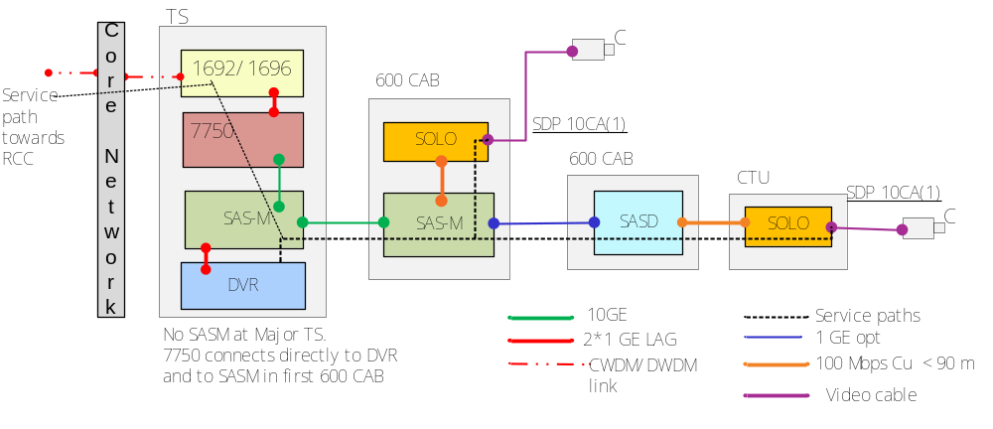
Figure 4 - Service Diagram for Service ST10CA1
The default SDP_Stream direction will be set in Circee as follows:
SDP10CA(1) -1.

Service type ST10CA2
Service Category 10 refers to CCTV Switched Video services.
- C --> stands for CODEC
- A --> stands for copper
- 2 --> Stands for two ports.
“For ST10CA2, CCTV video is supported by a copper cable infrastructure; it provides a 2 Ethernet port variant copper based Solo Codec within the equipment cabinet. It is deployed in non-resilient and resilient configurations.

Non-resilient Configurations
Configuration is:
- 2 port Solos in a daisy chain with a single / dual port Solo at the end of the chain, max four.
- The SDP location is the BNC connector on each solo.
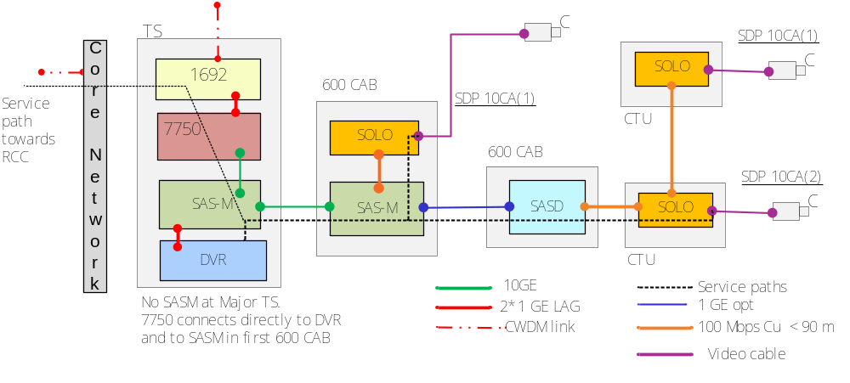
Figure 5 - Service Diagram for Service ST10CA2 (non-resilient)

Resilient Configurations
Configuration is:
The SDP location is the BNC connector on each solo.
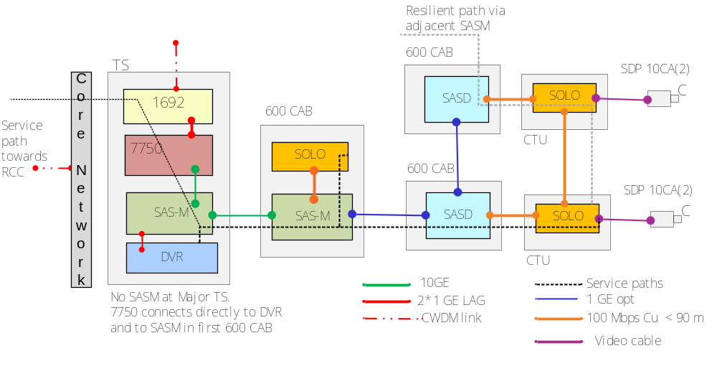
Figure 6 - Service Diagram for Service ST10CA2 (resilient)
The default SDP_Stream direction will be set in Circee as follows:
SDP10CA(2) -1.

Service Type ST10Cof1
Service Category 10 refers to CCTV Switched Video services.
- C --> stands for CODEC
- Of --> stands for Fibre
- 1 --> Stands for 1 Port.

For CCTV video supported by a fibre cable infrastructure;
Provision of 1 port optical based Solo Codec within an equipment cabinet. Please note that:
- The SDP location is the BNC connector on the solo.
- Non-resilient configuration.
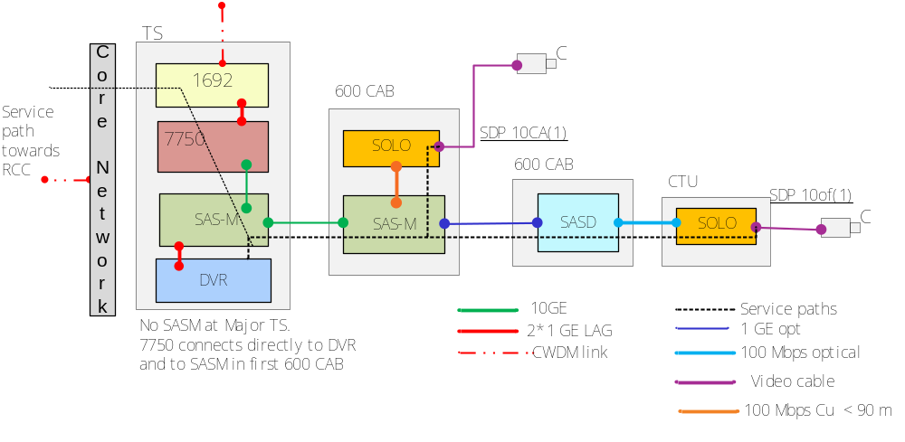
Figure 7 - Service Diagram for Service ST10Cof1
The default SDP_Stream direction will be set in Circee as follows:
SDP10Cof(1) -1.

Service Type ST10Cof2
Service Category 10 refers to CCTV Switched Video services.
- C --> stands for CODEC
- Of --> stands for Fibre
- 2 --> Stands for 2 Ports.
For CCTV video supported by a fibre cable infrastructure;
Provision of 2 ports optical based Solo Codec within an equipment cabinet

Non-resilient Configurations
Please note that the SDP location is BNC connector on each solo.
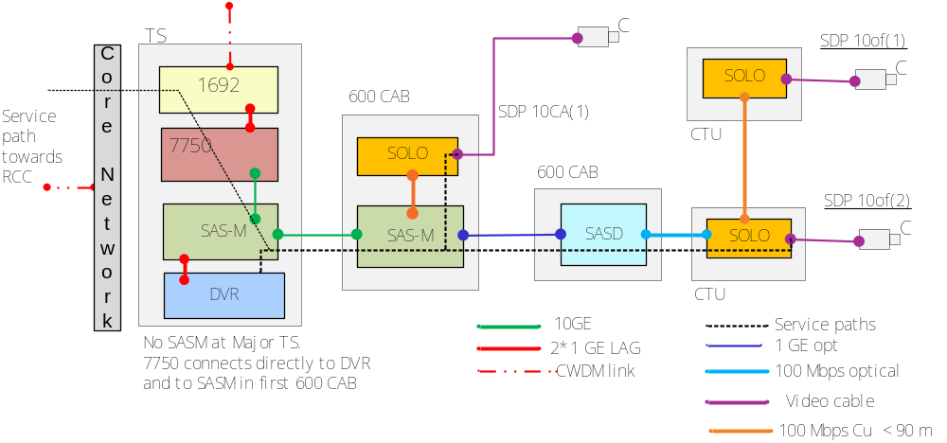
Figure 8 - Service Diagram for Service ST10Cof2 (non-resilient)

Resilient Configurations
Configuration is:
- 2 port Solos in a daisy chain terminating on adjacent SASD, max four.
- SDP location is BNC connector on each solo
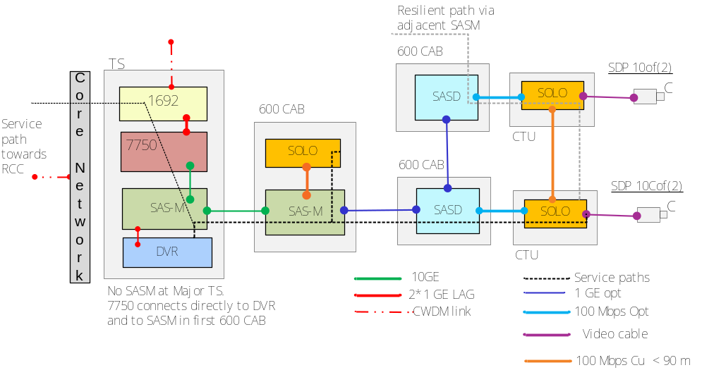
Figure 9 - ST10Cof2 (resilient)
The default SDP_Stream direction will be set in Circee as follows:
SDP10Cof(2) -1.
Please note: in some minor Transmission Stations, Digital Video Recorders may need to be moved from 7750s to 7210SAS-Ms. But since Digital Video Recorders are not part of any service definition, this will not affect any services in the OSS system.

Section 3: System Architecture

System Architecture

System Functional Architecture
Whilst there will be no change to the functional architecture of the overall OSS solution, some of the subsystems will be impacted. Section 4.1.1 below shows the functional architecture and interfaces involved in the end-to-end OSS solution. It also shows the subsystems that will be impacted by this work pack, such their set of capabilities will be extended in support of Managed Motorways Lite.

Functional Architecture Diagram
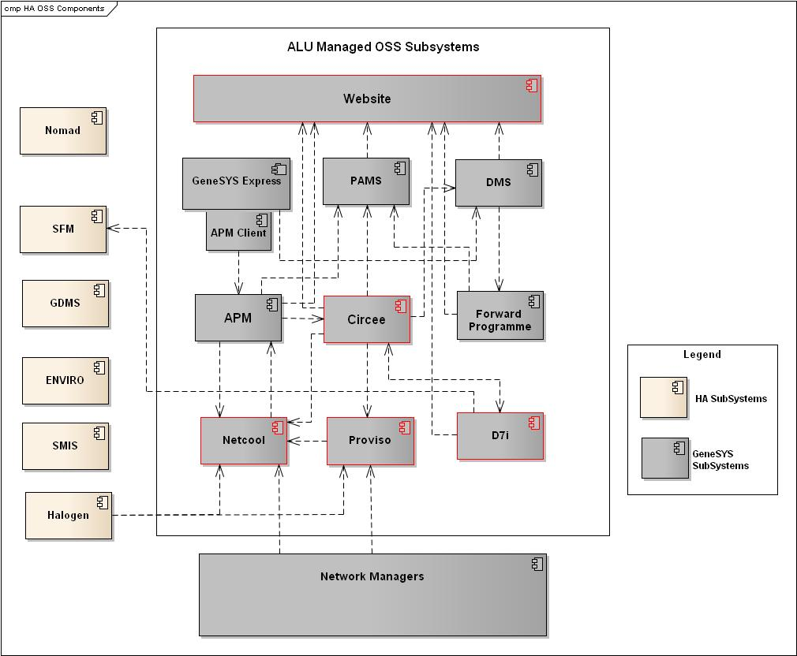
Figure 10 - Functional Architecture Diagram - Managed Motorways Lite IAMS

Description of System
The composition of the NRTS OSS is as illustrated above in Figure 10 - Functional Architecture Diagram - Managed Motorways Lite IAMS. Four sub-systems will be extended for MMLite: Netcool, Proviso, Circee and D7I; only the Netcool and Circee changes are in scope for MMLite IAMS.”
Description of System Changes
There are no new subsystems. There will be functional changes to the following subsystems:
- Netcool
- Circee.

Subsystem Functional Architectures

Netcool Functional Changes
Functional changes to Netcool are identified by the objects with red outline in Figure 11 - Netcool Functional Changes.
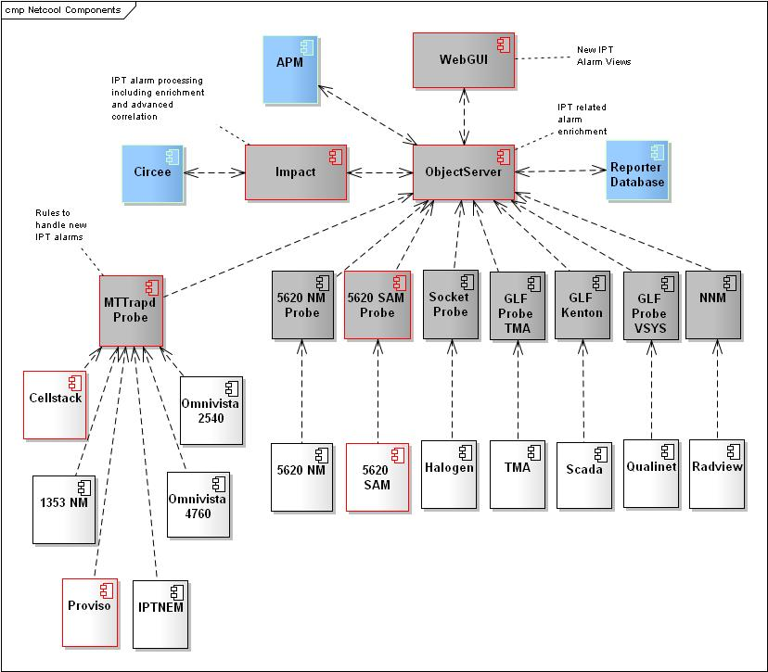
Figure 11 - Netcool Functional Changes

To provide the fault management capability in line with the SoR and the MMLite project specific requirements, the following changes will be made to the Netcool deployment. A number of new alarms will be introduced as a result of the MMLite deployment. These alarms are documented in appendix section 7.

Alarm Capture and Handling

The 5620 SAM probe will be upgraded to version 9 and regression-tested.

The 5620 SAM probe rules file and look up files will need to be updated to ensure the following events are captured, formatted and processed:
- Alarms coming from the new 7210SAS-M and 7210SAS-D (via the 5620 Sam element manager);
- Alarms from the existing 7750 device and the 5620 SAM Element Manager, which may be deprecated/amended/newly introduced as a result of the 5620 SAM upgrade to version 9.

Alarms from the Telindus Solo MPEG2 encoders, (generated by Cellstack, which sends them to the Mttrapd probe). are already being captured. Although the encoders are different variants to the ones already used in the network, their alarms remain the same. Hence no changes are needed in the Mttrapd probe in Netcool to capture them.

The 5620 Sam probe will be updated to ensure that event de-duplication and alarm clearing processing for Managed Motorways Lite alarms is fully supported.
The managed object names of the alarming components will be used as one of the fields to uniquely identify the alarms and will support alarm de-duplication.
The problem and corresponding resolution alarms will be identified in the alarm list. Where resolution alarms are not identified, appropriate expiry times will be set up for alarms.
There is a lookup table in the Sam 5620 probe which sets the three fields below according to values provided in the Alarm List. The three fields are:
Resilience-Affecting (Yes/NO)
Service-Affecting (Yes/No)
Action-Required (yes/No).

For the IAMS phase, 24 Service-Affecting Alarms have been agreed upon to be processed by Netcool.
All alarms not present in the AlarmList will be stored in Netcool, un-enriched, and not visible in the standard views (See section 3.2.1.3).

Note that the 5620 probe in the DMR site will also be upgrade to version 9, and the rules files will be synchronised with those in the Live system.

Alarm Enrichment
As per existingf functionality, the Netcool Impact new build policies will be used to enrich the new alarms coming from the 7210SAS-Ms and 7210SAS-Ds . The service affecting alarms will be enriched with STI impact details as per the existing functionality.
For the IAMS phase, all values for “Service Affecting”, “Resilience Affecting” and ”Action Required” fields will be set only according to he values in the rules file.
The Telindus Solo MPEG2 Encoder alarms will be enriched from information of Circee as is already happening. All that is required is the data input into Circee, No change required in Netcool.

Webtop Configuration
Netcool WebGUI views will be created to display Managed Motorway Lite alarms in line with NOC requirements:
- A view to display all alarms coming from the new 7210SAS-M, 7210SAS-D service access switches and the Telindus Solo MPEG2 Encoders.
- A view to display service-affecting MMLite alarms;
- A view to display all non-service-affecting MMLite alarms;
- A view to display all MMLite alarms where an Action is required.
- A view to display all MMLite Resilience Affecting.

Parent/Child correlation
This will be covered in Phase 2.

Outage Triggers

Outage Triggers

Service 8
Where there is a Service 8 device hanging from a directly for a 7210SAS-M or a 7210SAS-D, the loss of a port connection will result in an outage. If, on the other hand, the port is a pass point for IPT, this will be picked up by the IPT triggers.

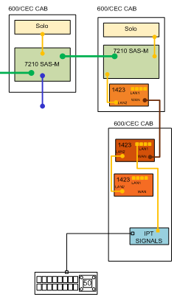

1) Loss of Link from
- Trigger
  - LinkDown alarm received from 5620 Element Manager for a 7210SAS-M or a 7210SAS-D
- output
  - Automated Trouble Ticket generated in APM enriched with detail of all STIs affected;

Service 10
There is no need to concern ourselves with 7210SAS-M or 7210SAS-D alarms. A service outage condition is represented by one of two alarms generated by the Cellstack element manager: either a camera is lost or there is an isolation of the Solo Telindus Mpeg2 Encoder. These two conditions are represented by the diagram below:

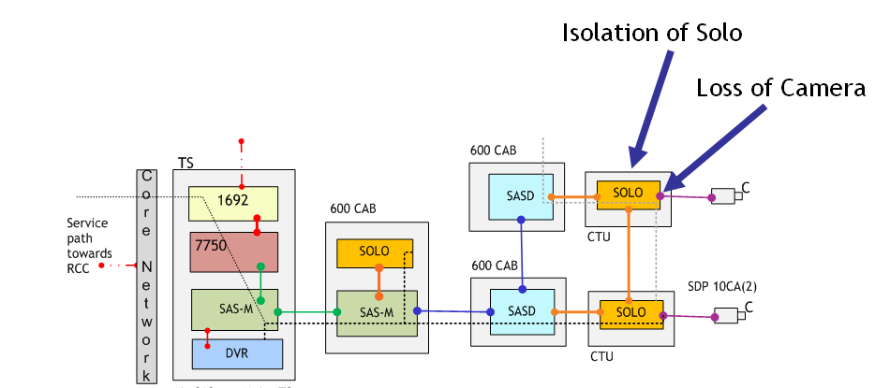
1) TelindusSolo MPEG2 Encoder isolated:
- Trigger
  - csNmsTrapLossOfConnection alarm received from Cellstack element manager
- output
  - Automated Trouble Ticket generated in APM enriched with detail of all STIs affected;

2) Camera lost:
- Trigger
  - BoardNoVideoSync alarm received from Cellstack element manager
- output
  - Automated Trouble Ticket generated in APM enrichd with detail of all STIs affected;

Circee Functional Changes

Circee Requirements Mapping
To support the Management Motorway deployment, the following requirements have been identified. The full list of requirements including deferred and obsolete requirements can be found in section 7.1
Business Requirements | Functional Requirements
BR494: The solution shall allow a QDT User to create, read, update and delete all the new Civil Infrastructure (e.g. Chambers, Ducts, Equipment Site) required to manage the new network. | No New FRs – existing functionality
BR495: The solution shall allow a QDT User to create, read, update and delete all the new Passive Telecom Infrastructure (e.g. Cables, Fibres) required to manage the new network equipment. | No New FRs – existing functionality
BR496: The solution shall allow a QDT User to create, read, update and delete all the new Active Telecom Infrastructure (e.g. Network Device and its Components) required to manage the new network equipment. | FR582: New catalogue items and templates shall be created within the Inventory Management system for the 7210SAS-M. There is an AC variant and a DC variant.  AC variant:  o 1GE_SFP port (occurs 24 times)  o 10GE_XFP port (occurs 2 times)  o PSU Port  o Console Port  o Management Port  o FAN  o AC PSU  The DC variant is identical to the AC variant described above, apart from the fact that the last item will be a DC PSU rather than an AC PSU.  Both the AC variant and the DC variant may optionally have an MDA with two 10GE_XFP ports.
FR662: New catalogue items and templates shall be created within the Inventory Management system for the 7210SAS-D. Unlike the 7210SAS-M, the 7210SAS_D will always have the same attributes, as there are no variants or optional extras.
o 1GE_SFP port (occurs 6 times)
o 1GE_BTX port (occurs 4 times)
o Console_Port
o PSU_Port
 | FR663: A new template needs to be created for the Copper-based Telindus Solo MPeg2 encoder with two ports. Catalogue items and a templates already exist in the Inventory Management system for the Copper-based Telindus Solo MPeg2 encoder with one port.
FR664: A new catalogue item (Optical fast port) and templates shall be created within the Inventory Management system for the fibre-based Telindus Solo Mpeg2 Encoder. There are two variants.

Single port variant:
o LAN port (occurs twice)
o Optical Fast Ethernet port
o Video in port
o Console data port (occurs twice)
The two_port variant will have an extra Optical fast Ethernet port
BR497: The solution shall allow a QDT User to create, read, update and delete all the new Services to be delivered over the Network. | FR583: The existing functionality of the Service Schedule within the Inventory Management system (which allows creation, modification and deletion of Service Type Instances) shall be extended to the following new Service Types: ST8RDH ST10CA1 ST10CA2 ST10Cof1 ST10Cof2
BR498: The solution shall allow the creation of new configurations of Infrastructure (e.g. attributes implemented via Asset Templates). | NOTE - Comment from RequisitePro: 08/02/2012: Marked as Duplicate of BR496 - to be agreed as duplicate with John Powers during HLD review. The FRs related to BR496 provide this information
BR500: The solution shall support updates to the Service Templates based on the agreed Infrastructure Scenarios (including topology - to be agreed during design). | FR587: The existing functionality of the inventory system which allows each Service Type Instance to include the links between the ports in each corresponding device shall be extended to the Service Types listed below:  ST8RDH  ST10CA1  ST10CA2  ST10Cof1  ST10Cof2
BR501: The agreed Infrastructure Scenarios shall be documented within the Service Template. | FR588: The system shall support representation of the Infrastructure Scenarios within the Service Templates.
BR502: The solution shall provide the geographic location for all new Infrastructure items, and display on the GIS maps. | FR589: The existing functionality of the inventory system which displays the geographic location of each asset on the GIS maps shall be extended to represent the new equipment types, i.e: o 7210SAS-M o 7210SAS-D o Telindus Solo Mpeg 2 Encoder - 1 port optical based Solo o Telindus Solo Mpeg 2 Encoder - 2 port optical based Solo o Telindus Solo Mpeg 2 Encoder - 1 port copper based Solo o Telindus Solo Mpeg 2 Encoder - 2 port copper based Solo
BR503: The solution shall have any new Service Types modelled within the Service Schedule, prior to delivery of the OSS Solution. | FR583: The existing functionality of the Service Schedule within the Inventory Management system (which allows creation, modification and deletion of Service Type Instances) shall be extended to the following new Service Types: ST8RDH ST10CA1 ST10CA2 ST10Cof1 ST10Cof2
BR504: The solution shall allow an Active Telecom Infrastructure item to be uniquely identifiable, regardless of location. | FR590: Each Active Telecom asset shall have a unique identifier within the Inventory Management system. Note that location may be a component of the Identifier, but it shall always be just a component of the identifier.
Table 3 - Circee Requirements Coverage

Circee Change Description
To provide the required support for Inventory and Asset Management processes, the following changes are required to be made in Circee.
- The Creation of new active equipment templates
The table below lists the equipment catalogue items and templates which will be required in Circee to support the Managed Motorways Lite deployment. Further details of the components required for the template can be found in the accompanying Circee Asset Template spreadsheet [8].
Equipment Catalog Items | Equipment templates
7210SAS Component  1. 7210SAS_1GE_SFP  2. 7210SAS_1GE_BTX  3. 7210SAS_10GE_XFP  4. 7210SAS_Mngt_Port  5. 7210_Console_Port  6. 7210SAS_MDA_2X10GE  7210 SAS-M specific component  7. 7210SASM_Subrack  8. 7210SASM_FAN  9. 7210SASM_AC_PSU  10. 7210SASM_DC_PSU  11. 7210SASM_PSU_Port  7210SAS-D specific component  12. 7210SASD_Subrack  13. 7210SASD_PSU_Port  Cellstack Solo  13. Solo_Subrack (already exists) *  14. Solo_S_Subrack  15. Solo_S_SO_Subrack  16. Solo_S_DO_Subrack  18. Solo_Video Port  19. Solo_Optical_Port  2o. Solo_Console_Port  21. Solo_LAN_Port (already exists) | 1. 7210_MDA_2X10GE  2. 7210SAS-M_AC  3. 7210SAS-M_AC_MDA  4. 7210SAS-M_DC  5. 7210SAS-M_DC_MDA  6. 7210SAS-D  7. Solo_Subrack (already exists) *  8. Solo_S_Subrack  9. Solo_S_SO_Subrack  10. Solo_S_DO_Subrack
* Please note that the catalog items Solo_Subrack and Solo_Port and the template Solo_Subrack already exist from previous work packages, but they are being listed here for completeness.
Table 4 - Catalogs and Templates

- Updates to Circee will be required to support the new service types below. These services will be available as service type option.
  - ST8RDH
  - ST10CA1
  - ST10CA2
  - ST10Cof1
  - ST10Cof2.
- New GIS Map overlays and associated SPC rules – to be confirmed.
- Updates to the topology tables (including L1 and L2 tables) to support the new network topology and infrastructure scenarios. The content and data format will be documented in the low level design documentation.
- Bulk data population for STI, Asset, and Topology data is provided by WP 186, while WP 180 allows the bulk creation and updating of the Topology tables. There are no further changes to the basic capability provided by the WP 180 and WP 186 scripts for managed Motorways Lite.
- Provision of a service template which reflects the infrastructure scenario.
In Figure 12 - Circee Component Design Changes below, the areas where these changes are expected are highlighted in red.
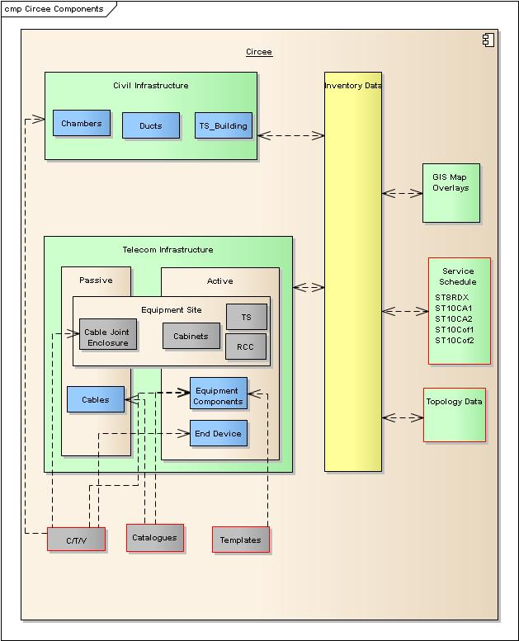
Figure 12 - Circee Component Design Changes

Circee Deliverables
The design deliverables from this work package are listed in the table below. While listed on separate rows, these may all be delivered as one patch:
- Circee patch to include support for new services
- Circee patch to include support for new devices and sub-components
- Supporting documentation

Circee Deliverable verification
The functionality delivered by work package 199 which has been described needs to be tested and verified.
The test cases should cover the following:-
- Full coverage of the requirements detailed in section 4.2.2.1
- Functionality providing support of modelling the new device, sub components and templates as detailed in the accompanying Circee Asset Templates spreadsheet [8] .
- The new service types (8RDH, ST10CA1, ST10CA2, ST10Cof1, ST10Cof2) must be available for selection from Circee.
- Non functional tests to ensure that the performance of Circee will not be adversely affected by the support of the Managed Motorways Lite deployment.

MMLite Device naming Convention
The devices to be introduced will follow a naming convention which will allow the easy identification of the unique MMLite instances in the network. It will follow the general naming convention for the existing new build services in the network, with variations to allow the identification of MMLite devices.

Data model

High Level Data Model

System Logical Data Model – End to End Work Pack View
The following diagram shows the databases resident in all OSS subsystems involved in the solution and the connectivity between them.
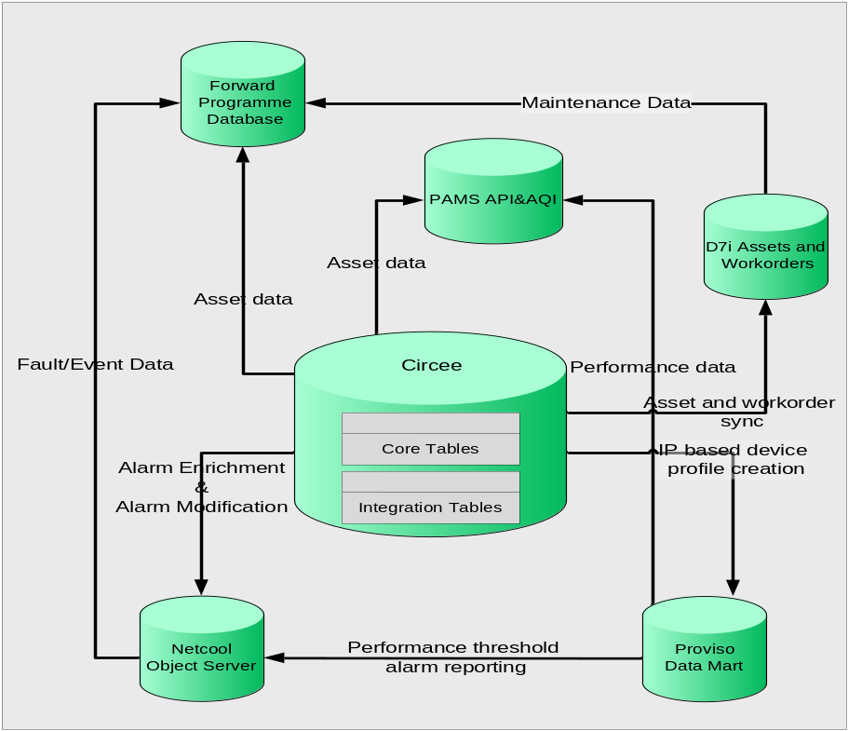
Figure 13 - High Level Data Model

The table below lists the data repositories that are shown in the figure above. The table provides a brief description of each and what changes are required as a result of this work package.
OSS Subsystem | Data Model Function | Work Package Changes
Netcool (ObjectServer and Reporter) | This in memory database which is deployed as part of Netcool serves as a repository for alarm and Netcool data. | There will be no change to the ObjectServer data model as part of this work pack.
Circee | The Circee data model stores asset, services and topology data. The database stores data which describes each type of asset and service in the form of catalogue items, templates and the service schedule. | There will be no change to the Circee data model. The appropriate tables will be updated with specific data to enable support for MMLITE assets and service. The tables to be updated will be detailed in the low level design documentation.
D7i Assets and Work Orders | The D7i database is an Oracle 9i database which holds all the asset and work order information. The asset data is populated by a scheduled job which imports asset data from Circee. This database also stores information regarding all planned maintenance schedules. | The existing data model will be updated with new instance data to support the MMLITE devices.
PAMS | PAMS stores data collected from a number of sources including Circee, D7i, APM, DMS and Proviso. This data is combined into several metrics using predictive models with the aim of predicting events that could cause failure and outages before. | No changes to the PAMS data model will be required to implement these work packages
Proviso Data Mart | The Proviso DataMart stores data collected and processed by Proviso DataChannel and Proviso DataLoad | Proviso is out of scope for this work package.
Figure 14 - Data Repository Changes

Netcool Logical Data Model
There is no change to the Netcool logical data model as a result of this data package.

Circee Logical Data Model
All Data model changes for Circee will be captured within the Circee Asset Templates [8].

Data Ownership Principle
This section describes the ownership of data for all the OSS subsystems where applicable.
OSS Subsystem | Data Component | Owner | Rules
Netcool (ObjectServer) | Alerts tables | Fluor/HA | The data is received from the Network and stored in the ObjectServer. Once deleted and archived, the data will be stored in the historical alarms database
Netcool (ObjectServer) | Parent/Child Relationship tables | ALU/Fluor | The tables are populated with the relevant data by ALU as part of the OSS SDLC. In principle, Fluor can update the tables as required.
Circee | Asset and Service Templates  Metadata creation for all other objects like cables and civil infrastructure if required will be performed by Fluor post OSS deployment and prior to data population dependent on the presence of this metadata. | ALU | Metadata creation for equipment sites and equipment components will be performed by ALU as part of OSS SDLC. This task will accomplished by designing and developing catalogue items and templates.
Circee | Asset and Service Instance Data | ALU/Fluor | Quinton Data Team will be responsible for data population relating to any moves, adds, and changes to the MMLITE deployment.
Figure 15 - Data Ownership

Use Cases
This section details Use Cases impacted by the delivery of the IAMS phase for Managed Motorways Lite

Inventory Management
The figure below shows the Use Case diagram for the whole of Inventory Management. The sections below this figure provide the specific details of the Use Case changes to be made for MMLite.
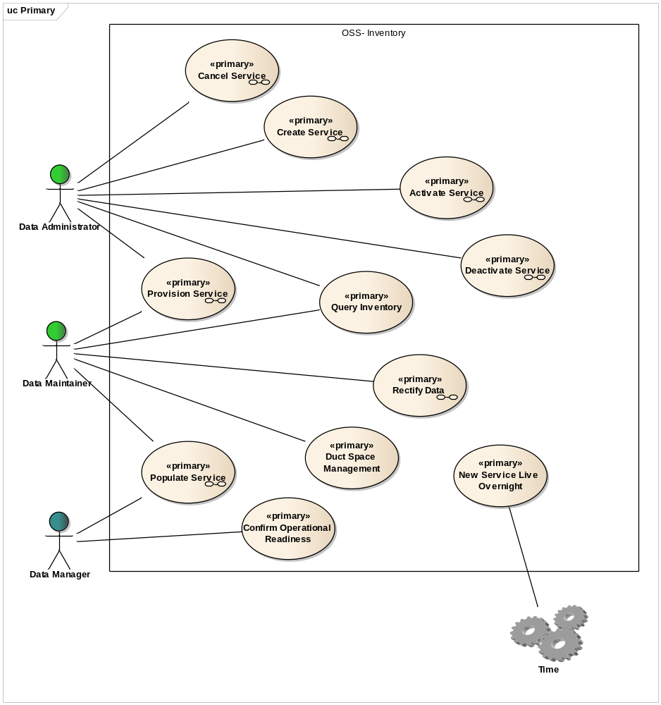
Figure 16 - Inventory Management Use Case diagram

Create Service
The figure below is an Activity diagram for this Use Case and details the ‘activities’ required to complete this task. This Activity diagram summarises the full Use Case.
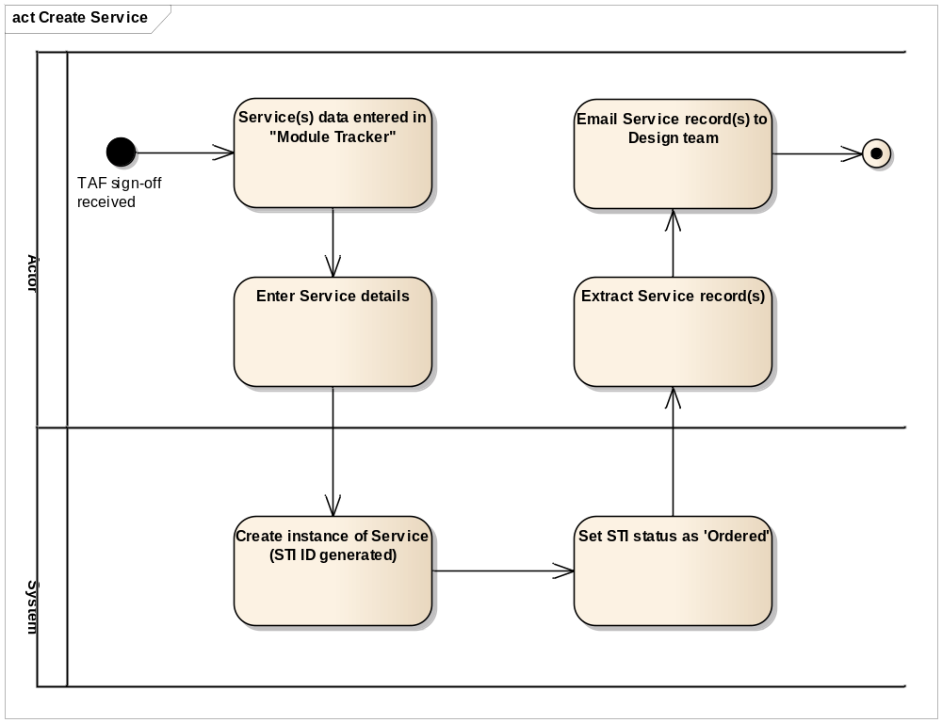
Figure 17 - Create Service Activity diagram
There is no change to the Create Service Use Case as referenced in [9] in Section 1.4. This Use Case will be instantiated for MM Lite. The information below will be used for that instantiation.

Supplementary Information
The following details the supplementary information required to provide the specific details related to Managed Motorways Lite:
Basic Flow - Create Service Shell from TAF, Step 3, Sub-step a.
- FR583: The existing functionality of the Service Schedule within the Inventory Management system (which allows creation, modification and deletion of Service Type Instances) shall be extended to the following new Service Types:
- ST8RDH
- ST10CA1
- ST10CA2
- ST10Cof1
- ST10Cof2

Populate Service
The figure below is an Activity diagram for this Use Case and details the ‘activities’ required to complete this task. This Activity diagram summarises the full Use Case.
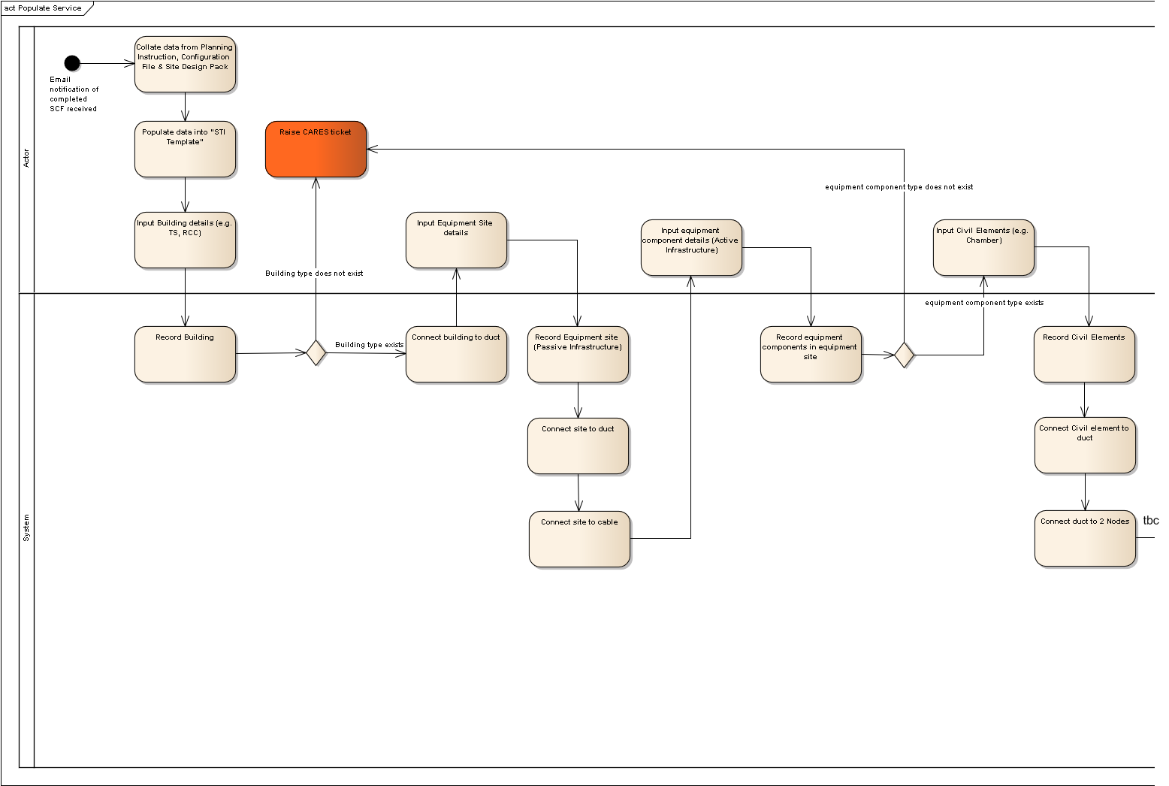
Figure 18: Populate Service Activity diagram (Pt1 of 2)
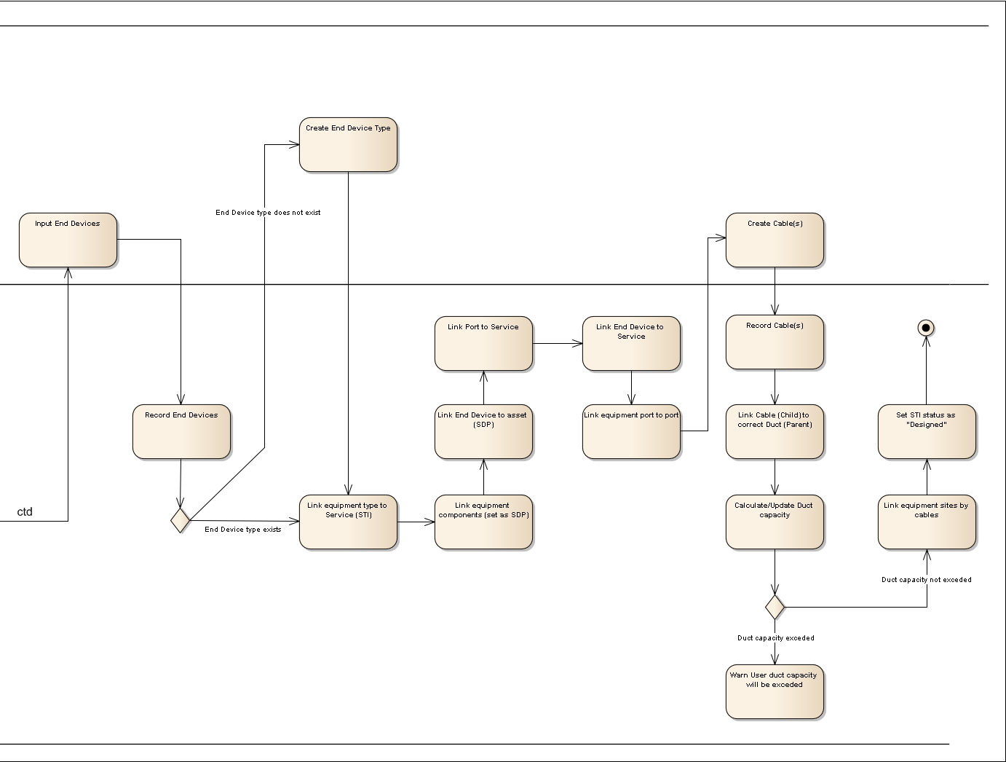
Figure 19 - Populate Service Activity diagram (Pt 2 of 2)
There is no impact to the Populate Service Use Case as referenced in [10] in Section 1.4. This Use Case will be instantiated for MM Lite. The information below will be used for that instantiation.

Supplementary Information
The following details the supplementary information required to provide the specific details related to Managed Motorways Lite:
Basic Flow – Populate Service, Step 2.
- FR588: The system shall support representation of the Infrastructure Scenarios within the Service Templates.
Basic Flow – Populate Service, Step 7, Sub-step a and b.
- FR582: New catalogue items and templates shall be created within the Inventory Management system for the 7210SAS-M.
There is an AC variant and a DC variant.
AC variant:
o 1GE_SFP port (occurs 24 times)
o 10GE_XFP port (occurs 2 times)
o PSU Port
o Console Port
o Management Port
o FAN
o AC PSU
The DC variant is identical to the AC variant described above, apart from the fact that the last item will be a DC PSU rather than an AC PSU
Both the AC variant and the DC variant may optionally have an MDA with two 10GE_XFP ports.
- FR662: New catalogue items and templates shall be created within the Inventory Management system for the 7210SAS-D.
Unlike the SAS_M, the SAS_D will always have the same attributes, as there are no variants or optional extras.
o 1GE_SFP port (occurs 6 times)
o 1GE_BTX port (occurs 4 times)
o Console_Port
o PSU_Port
- FR663: A new template needs to be created for the Copper-based Telindus Solo MPeg2 encoder with two ports. Catalogue items and templates already exist in the Inventory Management system for the Copper-based Telindus Solo MPeg2 encoder with one port.
Basic Flow – Populate Service, Step 13.
- FR587: The existing functionality of the inventory system which allows each Service Type Instance to include the links between the ports in each corresponding device shall be extended to the Service Types listed below:
- ST8RDH
- ST10CA1
- ST10CA2
- ST10Cof1
- ST10Cof2
Basic Flow – Populate Service, Step 18, Sub-step b.
- FR589: The existing functionality of the inventory system which displays the geographic location of each asset on the GIS maps shall be extended to represent the new equipment types, i.e:
o 7210SAS-M
o 7210SAS-D
o Telindus Solo Mpeg 2 Encoder - 1 port optical based Solo
o Telindus Solo Mpeg 2 Encoder - 2 port optical based Solo
o Telindus Solo Mpeg 2 Encoder - 1 port copper based Solo
o Telindus Solo Mpeg 2 Encoder - 2 port copper based Solo

Provision Service
The figure below is an Activity diagram for this Use Case and details the ‘activities’ required to complete this task. This Activity diagram summarises the full Use Case.
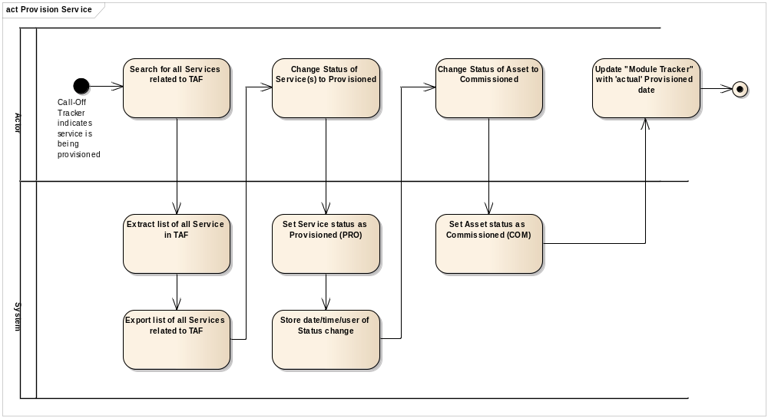
Figure 20 - Provision Service Activity diagram
There is no impact to the Provision Service Use Case as referenced in [11] in Section 1.4. This Use Case will be instantiated for MM Lite. The information below will be used for that instantiation.

Supplementary Information
The following details the supplementary information required to provide the specific details related to Managed Motorways Lite:
Basic Flow – Provision Service, Step 3, Sub-step a.
- FR583: The existing functionality of the Service Schedule within the Inventory Management system (which allows creation, modification and deletion of Service Type Instances) shall be extended to the following new Service Types:
- ST8RDH
- ST10CA1
- ST10CA2
- ST10Cof1
- ST10Cof2

Activate Service
The figure below is an Activity diagram for this Use Case and details the ‘activities’ required to complete this task. This Activity diagram summarises the full Use Case.
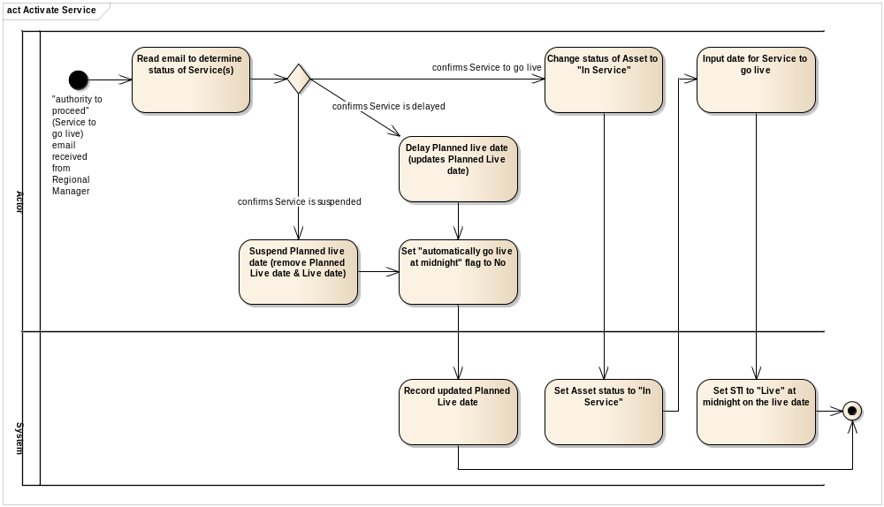
Figure 21 - Activate Service Activity diagram
There is no impact to the Activate Service Use Case as referenced in [12] in section 1.4. This Use Case will be instantiated for MM Lite. The information below will be used for that instantiation.

Supplementary Information
The following details the supplementary information required to provide the specific details related to Managed Motorways Lite:
Basic Flow – Activate Service, Step 3, Sub-step a.
- FR583: The existing functionality of the Service Schedule within the Inventory Management system (which allows creation, modification and deletion of Service Type Instances) shall be extended to the following new Service Types:
- ST8RDH
- ST10CA1
- ST10CA2
- ST10Cof1
- ST10Cof2

Deactivate Service
The figure below is an Activity diagram for this Use Case and details the ‘activities’ required to complete this task. This Activity diagram summarises the full Use Case.
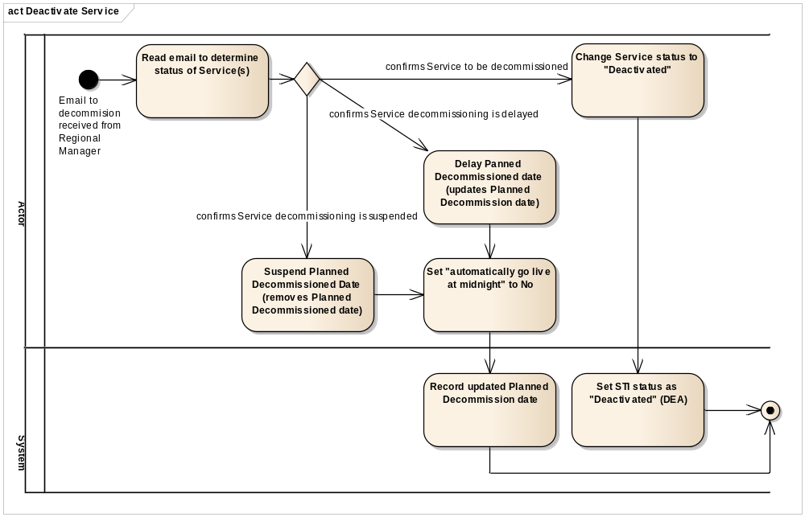
Figure 22 - Decommission Service Activity diagram
There is no impact to the Deactivate Service Use Case as referenced in [13] in Section 1.4. This Use Case will be instantiated for MM Lite. The information below will be used for that instantiation.

Supplementary Information
The following details the supplementary information required to provide the specific details related to Managed Motorways Lite:
Basic Flow – Deactivate Service, Step 3, Sub-step a.
- FR583: The existing functionality of the Service Schedule within the Inventory Management system (which allows creation, modification and deletion of Service Type Instances) shall be extended to the following new Service Types:
• ST8RDH
• ST10CA1
• ST10CA2
• ST10Cof1
• ST10Cof2

Rectify Data
The figure below is an Activity diagram for this Use Case and details the ‘activities’ required to complete this task. This Activity diagram summarises the full Use Case.
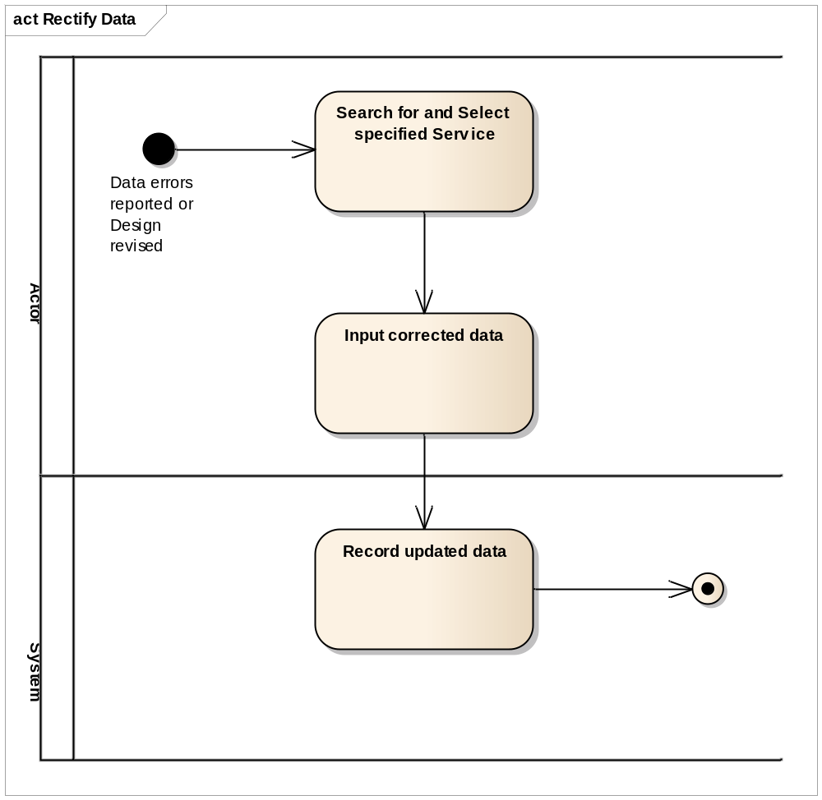
Figure 23 - Rectify Data Activity diagram
There is no impact to the Rectify Data Use Case as referenced in [14] in Section 1.4. This Use Case will be instantiated for MM Lite. The information below will be used for that instantiation.

Supplementary Information
The following details the supplementary information required to provide the specific details related to Managed Motorways Lite:
Basic Flow – Rectify Data, Step 2.
- FR582: New catalogue items and templates shall be created within the Inventory Management system for the 7210SAS-M.
There is an AC variant and a DC variant.
AC variant:
o 1GE_SFP port (occurs 24 times)
o 10GE_XFP port (occurs 2 times)
o PSU Port
o Console Port
o Management Port
o FAN
o AC PSU
The DC variant is identical to the AC variant described above, apart from the fact that the last item will be a DC PSU rather than an AC PSU
Both the AC variant and the DC variant may optionally have an MDA with two 10GE_XFP ports.
- FR662: New catalogue items and templates shall be created within the Inventory Management system for the 7210SAS-D.
Unlike the SAS_M, the SAS_D will always have the same attributes, as there are no variants or optional extras.
o 1GE_SFP port (occurs 6 times)
o 1GE_BTX port (occurs 4 times)
o Console_Port
o PSU_Port
- FR663: A new template needs to be created for the Copper-based Telindus Solo MPeg2 encoder with two ports. Catalogue items and a templates already exist in the Inventory Management system for the Copper-based Telindus Solo MPeg2 encoder with one port.
- FR587: The existing functionality of the inventory system which allows each Service Type Instance to include the links between the ports in each corresponding device shall be extended to the Service Types listed below:
- ST8RDH
- ST10CA1
- ST10CA2
- ST10Cof1
- ST10Cof2
- FR589: The existing functionality of the inventory system which displays the geographic location of each asset on the GIS maps shall be extended to represent the new equipment types, i.e:
o 7210SAS-M
o 7210SAS-D
o Telindus Solo Mpeg 2 Encoder - 1 port optical based Solo
o Telindus Solo Mpeg 2 Encoder - 2 port optical based Solo
o Telindus Solo Mpeg 2 Encoder - 1 port copper based Solo
o Telindus Solo Mpeg 2 Encoder - 2 port copper based Solo
- FR590: Each Active Telecom asset shall have a unique identifier within the Inventory Management system. Note that location may be a component of the Identifier, but it shall always be just a component of the identifier.

Cancel Service
The figure below is an Activity diagram for this Use Case and details the ‘activities’ required to complete this task. This Activity diagram summarises the full Use Case.
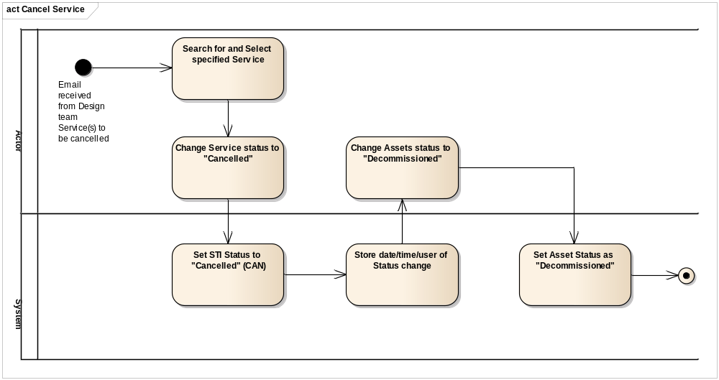
Figure 24 - Cancel Service Activity diagram
There is no impact to the Cancel Service Use Case as referenced in [15] in Section 1.4. This Use Case will be instantiated for MM Lite. The information below will be used for that instantiation.

Supplementary Information
The following details the supplementary information required to provide the specific details related to Managed Motorways Lite:
Basic Flow – Cancel Service, Step 2, Sub-step a.
- FR583: The existing functionality of the Service Schedule within the Inventory Management system (which allows creation, modification and deletion of Service Type Instances) shall be extended to the following new Service Types:
- ST8RDH
- ST10CA1
- ST10CA2
- ST10Cof1
- ST10Cof2
Basic Flow – Cancel Service, Step 3, Sub-step a.
- FR582: New catalogue items and templates shall be created within the Inventory Management system for the 7210-SAS-M.
There is an AC variant and a DC variant.
AC variant:
o 1GE_SFP port (occurs 24 times)
o 10GE_XFP port (occurs 2 times)
o PSU Port
o Console Port
o Management Port
o FAN
o AC PSU
The DC variant is identical to the AC variant described above, apart from the fact that the last item will be a DC PSU rather than an AC PSU
Both the AC variant and the DC variant may optionally have an MDA with two 10GE_XFP ports.
- FR662: New catalogue items and templates shall be created within the Inventory Management system for the 7210SAS-D.
Unlike the SAS_M, the SAS_D will always have the same attributes, as there are no variants or optional extras.
o 1GE_SFP port (occurs 6 times)
o 1GE_BTX port (occurs 4 times)
o Console_Port
o PSU_Port
- FR663: A new template needs to be created for the Copper-based Telindus Solo MPeg2 encoder with two ports. Catalogue items and a templates already exist in the Inventory Management system for the Copper-based Telindus Solo MPeg2 encoder with one port.

Fault Management
The figure below shows the Use Case diagram for the whole of Fault Management. The sections below this figure provide the specific details of the Use Case changes to be made for MM Lite.
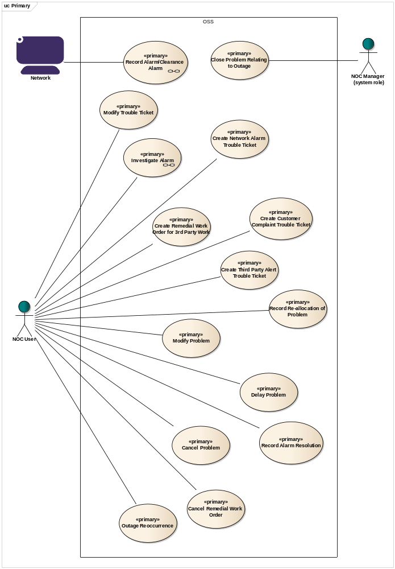
Figure 25 - Fault Management Use Case diagram

Record Alarm-Clearance Alarm
The figure below is an Activity diagram for this Use Case and details the ‘activities’ required to complete this task. This Activity diagram summarises the full Use Case.
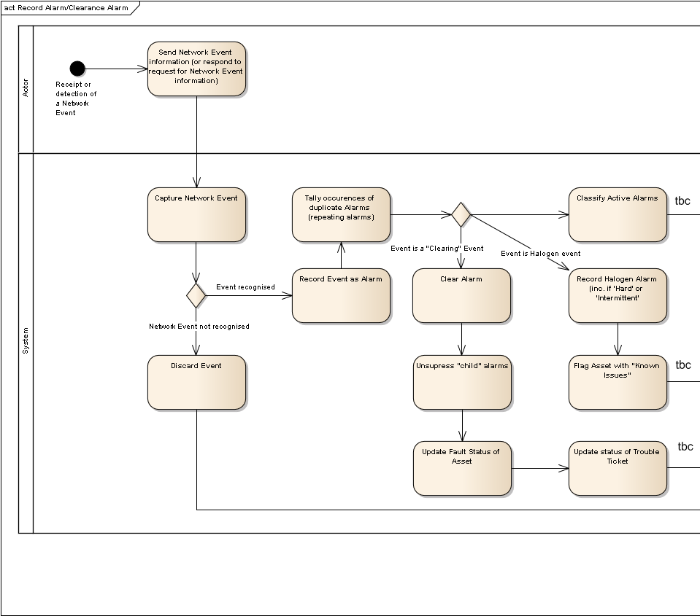
Figure 26: Record Alarm-Clearance Alarm Activity diagram (Pt 1 of 2)
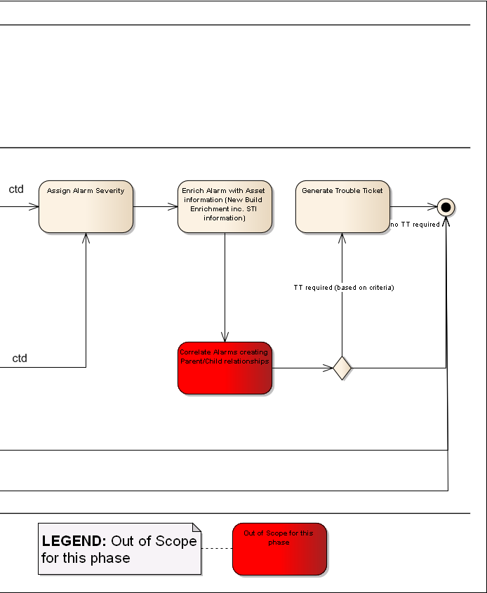
Figure 27 - Record Alarm-Clearance Alarm Activity diagram (Pt 2 of 2)
There is no impact to the Record Alarm-Clearance Alarm Use Case as referenced in [17] in Section 1.4. This Use Case will be instantiated for MM Lite. The information below will be used for that instantiation.

Supplementary Information
The following details the supplementary information required to provide the specific details related to Managed Motorways Lite:
Basic Flow – Raised Alarm, Step 1.
- FR628: Where an alarm that is not defined by the Alarm List is received by the Fault Management system, it shall store the alarm, without enrichment or correlation, as per the existing functionality.
Basic Flow – Raised Alarm, Step 2.
- FR595: The Netcool MTTRAPD probe shall receive alarms from the Cellstack relating to the Telindus Solo Mpeg 2 Encoder. These alarms shall be defined within an agreed Alarm List.
- FR596: The Netcool 5620 SAM probe shall receive events relating to the 7210SAS-Ms from the 5620 Sam. The alarms shall be defined within an agreed Alarm List.
- FR596.1: The Netcool 5620 SAM probe shall receive events relating to the 7210SAS-Ds from the 5620 Sam. The alarms shall be defined within an agreed Alarm List.
Basic Flow – Raised Alarm, Step 8.
- FR601: The existing "new build" enrichment process shall be applied to the alarms coming from the Telindus Solo MPEG 2 Encoders.
- FR601.1: The existing "new build" enrichment process shall be applied to the alarms coming from the 7210SAS-Ms.
- FR601.2: The existing "new build" enrichment process shall be applied to the alarms coming from the 7210SAS-Ds.
- FR614: The existing "new build" enrichment policy, which includes populating the alarm with impacted STIs and associated STI IDs, will be extended for Service affecting alarms coming from MM Lite devices (e.g. 7210SAS-M, 7210SAS-D, Telindus SOLO Encoder).
- FR671: The solution shall identify services critical to the business services e.g. loss of comms to Hard Shoulder Monitoring (HSM) camera(s) by enriching the alarm to identify the STI affected is Hard Shoulder impacting.
Alternative Flow – Network Alarm Trouble Ticket Generation, Step 2.
- FR618: For service affecting alarms, the fault management system shall raise a trouble ticket and notify the trouble-ticketing system with the relevant information.

Exceptions
- Section 1.1: No Parent/Child Relationships
- Section 1.6/Step 4: No Parent/Child Relationships
- Section 2.1/Step 9: No Parent/Child Relationships

Investigate Alarm
The figure below is an Activity diagram for this Use Case and details the ‘activities’ required to complete this task. This Activity diagram summarises the full Use Case.
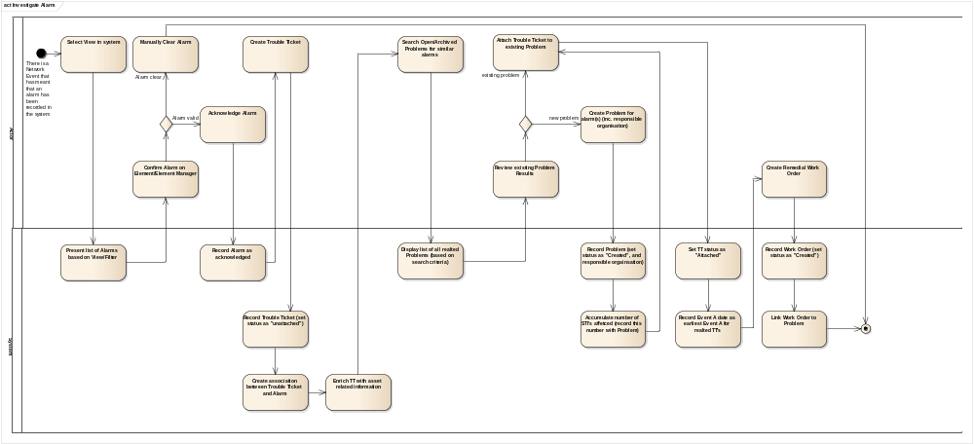
Figure 28 - Investigate Alarm Activity diagram
There is no impact to the Cancel Service Use Case as referenced in [18] in Section 1.4. This Use Case will be instantiated for MM Lite. The information below will be used for that instantiation.

Supplementary Information
The following details the supplementary information required to provide the specific details related to Managed Motorways Lite:
Basic Flow – Investigate Alarm and create Remedial Work Order, Step 1, Sub-step a.
- FR604: Filters shall be defined so that only relevant alarms are displayed to NOC operators.
- FR629: Where an alarm that is not defined by the Alarm List is received by the Fault Management system, the alarm shall not be displayed in the views normally used by the operators, but shall be available in separate views.
- FR631: The users shall be able to amend existing views and create additional views.
- FR632: A view that only displays MM Lite alarms shall be created within the Fault Management system.
- FR633: A view that only displays MM Lite Service Affecting alarms shall be created within the Fault Management system.
- FR672: The solution shall provide a Netcool view showing events affecting critical services e.g. loss of comms to Hard Shoulder Monitoring (HSM) camera(s).

Business Processes
No changes to the existing NOC business processes have been identified.

Data Flow
There are no changes to inter system data flows.

Interfaces

External Interface Changes
Not applicable.

Internal Interface Changes
Not applicable.

Section 4: Non Functional Architecture

Non-Functional Architecture
This section describes the changes to the non-functional capability of the system to support Work Package 199 and the new MMLite devices. Against each non-functional capability, it describes the hardware, software, network (data communications and management) and security elements impacted and the changes to be made to each.

Capacity and Dimensioning
A full and specific planning model cannot be produced at this stage. A performance monitoring and capacity modelling exercise needs to take place beforehand and this in turn needs to be performed on the upgraded Netcool deployment. A MMLite specific capacity model will be provided in the MMLite full solution phase (phase 3).
Documentation specifying the aforementioned performance monitoring and capacity modelling exercises will be provided as separate deliverables.
For now, this section discusses the aspects of capacity and dimensioning that need to be considered.
To ensure that the existing platform will be able to cater for the volume and rate of alarms that will be generated by the MMLite devices, a capacity and dimension modelling exercise will be carried out. The specific aims of the exercise are as follows.
To identify the current performance of the platforms with specific focus on
- CPU Utilisation
- Memory utilisation
To identify the current performance of the applications with a specific focus on
- Probe rules processing overhead
- Event rates
- The load on the ObjectServer (automations, client access etc).
The following IBM guidelines for sizing of hosting platforms are by the size of the managed network and the architecture employed, the HA Netcool deployment would fall into the category of a small or standard deployment due to its single tiered nature and relatively small number of resident events ( <50000).

Component | IBM Recommendation | Current Setup | Description
Standard ObjectServer | Cores:2  Memory: 4GB | Cores:4  Memory: 12GB | The ObjectServer is currently co-located with Impact. The ObjectServer being a 32 bit application can only ever use up to 4Gb of memory. In normal conditions, a standard Object Server will use 1-2 CPUS. It is not anticipated that any changes will be required to support the Managed Motorways Lite deployment
Probes | Cores:2  Memory: 2GB  (Per Probe) | Cores: 2  Memory: 8GB | Currently, there are 5 probes located in the same container. The current setup already crosses the limit of the IBM recommendations in terms of CPU cores.  In terms of memory usage, the probe will require some memory for storing the rules files on startup and for storing the traps in the queue. Each trap takes up 1500 + 128 bytes of memory. 0.5Mb should be allowed for particularly large rules files. This would mean the probe would require approximately 100Mb of memory. (calculated by(60000 * (1500 + 128))/1048576 + 0.5 Mb).
Table 5 - Server Sizing Guidelines

Migration
No change.

Availability
No change.

Back up and Restore
No change.

Data Storage
No change.

Security
No change

Reliability
No change.

SECTION 5: Impacted Functional Specification Documents

Impacted Functional Specification Documents
The documents listed in the table below will be updated to bring them in line with design changes as described in this high level document.
Sub System | Sub System | LLD / DSD Document Name
Fault Management | Netcool | GYSRGDSSP0007_R08 PS-DS036-07 FUNCTIONAL SPECIFICATION NETCOOL.doc
Inventory Management | Circee | GYSRGDSSP0009_R21 PS-DS036-05 Functional Specification Circee.doc
Table 6 - List of Impacted Functional Specification Documents

SECTION 6: Requirements and Solution Traceability

Requirements and Solution Traceability

Functional Requirements and Requirements Mapping
FR Tag | Requirement text | Status | Candidate Use Cases | Phase | Traced-to | DocSection | Compliance Status
FR643 | SAM 5620 Probe v9, Proviso Application Pack for SAM 9 will be added as new components to the DRC. | deferredProposed | Non-Functional | 190/199 Ph 2 - IAMS | BR526 | 3.2.1.1 | Full
FR586 | The network topology data required for the management of the new Network shall be fully populated with the agreed Infrastructure Scenario data. | Deferred | Manage Inventory Item | N/A | BR499(s) | N/A | N/A
FR646 | The solution shall allow bulk updates to attributes of the new Active Telecom Infrastructure. | Deferred | Manage Inventory Item | N/A | BR530(s) | N/A | N/A
FR584 | For the 7210SAS-M, a user shall be able to record the following port types:  SFP (24 ports)  XFP (2 ports) | Duplicate | Manage Inventory Item | 190/199 Ph 1c - Circee Assets | BR498(s) | N/A | N/A
FR585 | For the 7210SAS-D, a user shall be able to record the following port types: SFP (6 ports), RJ45 (4 ports),For the 7210SAS-D, a user shall be able to record the following port types:  SFP (6 ports)  RJ45 (4 ports) | Duplicate | Manage Inventory Item | 190/199 Ph 1c - Circee Assets | BR498(s) | N/A | N/A
FR580 | The solution shall allow a QDT User to create, read, update and delete all the new Civil Infrastructure (e.g. Chambers, Ducts, Equipment Site) required to manage the new network. | Incorporated | Manage Inventory Item | 190/199 Ph 1c - Circee Assets | BR494 |  | N/A
FR581 | The solution shall allow a QDT User to create, read, update and delete all the new Passive Telecom Infrastructure (e.g. Cables, Fibres) required to manage the new network equipment. | Incorporated | Manage Inventory Item | 190/199 Ph 1c - Circee Assets | BR495 |  | N/A
FR582 | New catalogue items and templates shall be created within the Inventory Management system for the 7210SAS_M.  There is an AC variant and a DC variant.  AC variant:  o 1GE_SFP port (occurs 24 times)  o 10GE_XFP port (occurs 2 times)  o PSU Port  o Console Port  o Management Port  o FAN  o AC PSU  The DC variant is identical to the AC variant described above, apart from the fact that the last item will be a DC PSU rather than an AC PSU  Both the AC variant and the DC variant may optionally have an MDA with two 10GE_XFP ports. | Proposed | Manage Inventory Item | 190/199 Ph 1c - Circee Assets | BR496(s) | 3.2.2.2 | Full
FR583 | The existing functionality of the Service Schedule within the Inventory Management system (which allows creation, modification and deletion of Service Type Instances) shall be extended to the following new Service Types:  ST8RDH  ST10CA1  ST10CA2  ST10Cof1  ST10Cof2 | Proposed | Manage Inventory Item |  | BR497, BR503 | 3.2.2.2 | Full
FR587 | The existing functionality of the inventory system which allows each Service Type Instance to include the links between the ports in each corresponding device shall be extended to the Service Types listed below:  ST8RDH  ST10CA1  ST10CA2  ST10Cof1  ST10Cof2 | Proposed | Manage Inventory Item | 190/199 Ph 1c - Circee Assets | BR500 | 3.2.2.2 | Full
FR588 | The system shall support representation of the Infrastructure Scenarios within the Service Templates. | Proposed | Manage Inventory Item | 190/199 Ph 2 - IAMS | BR501 | 3.2.2.2 | Full
FR589 | The existing functionality of the inventory system which displays the geographic location of each asset on the GIS maps shall be extended to represent the new equipment types, i.e:  o 7210SAS-M  o 7210SAS-D  o Telindus Solo Mpeg 2 Encoder - 1 port optical based Solo  o Telindus Solo Mpeg 2 Encoder - 2 port optical based Solo  o Telindus Solo Mpeg 2 Encoder - 1 port copper based Solo  o Telindus Solo Mpeg 2 Encoder - 2 port copper based Solo | Proposed | Manage Inventory Item | 190/199 Ph 1c - Circee Assets | BR502 |  | Full
FR590 | Each Active Telecom asset shall have a unique identifier within the Inventory Management system. Note that location may be a component of the Identifier, but it shall always be just a component of the identifier. | Proposed | Manage Inventory Item | 190/199 Ph 1c - Circee Assets | BR504 |  | Full
FR662 | New catalogue items and templates shall be created within the Inventory Management system for the 7210SAS-D.  Unlike the 7210SAS_M, the 7210SAS_D will always have the same attributes, as there are no variants or optional extras.  o 1GE_SFP port (occurs 6 times)  o 1GE_BTX port (occurs 4 times)  o Console_Port  o PSU_Port | Proposed | Manage Inventory Item |  | BR496(s) | 3.2.2.2 | Full
FR663 | A new template needs to be created for the Copper-based Telindus Solo MPeg2 encoder with two ports. Catalogue items and a templates already exist in the Inventory Management system for the Copper-based Telindus Solo MPeg2 encoder with one port. | Proposed | Manage Inventory Item |  | BR496 | 3.2.2.2 | Full
FR664 | A new catalogue item (Optical fast port) and templates shall be created within the Inventory Management system for the fibre-basedTelindus Solo Mpeg2 Encoder. There are two variants.  Single port variant:  o LAN port (occurs twice)  o Optical Fast Ethernet port  o Video in port  o Console data port (occurs twice)  The two_port variant will have an extra Optical fast Ethernet port | Proposed | Manage Inventory Item |  | BR496 | 3.2.2.2 | Full
FR591 | The existing functionality of the Maintenance system shall be extended to include activity profiles for the following assets and sub-components:  7210SAS-M  o 1 Subrack  o 2 power supply modules  7210SAD-D  o 1 Subrack  o 2 power supply modules  Telindus Solo Mpeg 2 Encoder - 1 port optical based Solo  Telindus Solo Mpeg 2 Encoder - 2 port optical based Solo | Deferred | Manage Maintenance Profiles | 190/199 Ph 3 - Full Solution | BR505 | N/A | N/A
FR592 | The existing functionality of the Maintenance system shall be extended to include inspection profiles for the following assets and sub-components:  7210SAS-M  o 1 Subrack  o 2 power supply modules  7210SAD-D  o 1 Subrack  o 2 power supply modules  Telindus Solo Mpeg 2 Encoder - 1 port optical based Solo  Telindus Solo Mpeg 2 Encoder - 2 port optical based Solo | Deferred | Manage Maintenance Profiles | 190/199 Ph 3 - Full Solution | BR505 | N/A | N/A
FR593 | The existing functionality of the Maintenance system shall be extended to include activity profiles for the following Civil infrastructure items: | N/A | Manage Maintenance Profiles |  | BR505(s) | N/A | N/A
FR594 | The existing functionality of the Maintenance system shall be extended to include inspection profiles for the following Civil infrastructure items: | N/A | Manage Maintenance Profiles |  | BR505(s) | N/A | N/A
FR620 | For each defined fault case, the ultimate parent shall be agreed with the NOC. | Deferred | Correlate Alarm | 190/199 Ph 4 - Correlation (P/C) | BR515 | N/A | N/A
FR621 | When a agreed fault case occurs, the fault management system shall perform parent-child correlation, display the parent alarms and hide the children alarms. | Deferred | Correlate Alarm | 190/199 Ph 4 - Correlation (P/C) | BR515 | N/A | N/A
FR627 | Where a parent event has been cleared, its previously suppressed children shall be unsupressed after an appropriate waiting period, apart from the child alarms that are cleared via the expiry mechansim - these will remain suppressed. | Deferred | Correlate Alarm | 190/199 Ph 4 - Correlation (P/C) | BR516 | N/A | N/A
FR613 | Netcool will display the impacted STI ID's for each resilience affecting alarm. | Deferred | Display Alarm | 190/199 Ph 3 - Full Solution | BR512 | N/A | N/A
FR612 | The existing "new build" enrichment policy, which includes populating the alarm with impacted STIs and associated STI IDs, will be extended for Resilience affecting alarms coming from MM Lite devices (e.g. 7210SAS-M, 7210SAS-D, Telindus SOLO Encoder). | Deferred | Enrich Alarm | 190/199 Ph 3 - Full Solution | BR512 | N/A | N/A
FR617 | For resilience affecting alarms, the fault management system shall raise a trouble ticket and send the relevant information to the trouble-ticketing system. | Deferred | Raise Trouble Ticket | 190/199 Ph 3 - Full Solution | BR513(s) | N/A | N/A
FR597 | The 5620 probe shall continue receiving alarms from the 7750's via the 5620 SAM. Any new alarms coming from the 7750's as a result of the upgrade of the 5620 SAM to Rev9 shall be defined within an agreed Alarm List and processed by the SAM Probe. | Deferred | Record Alarm | 190/199 Ph 1d - Pre-requisites | BR506 | N/A | N/A
FR598 | Any new alarms coming from the 5620 SAM itself as a result of the upgrade shall also be defined within an agreed Alarm List and processed by the SAM Probe. | Deferred | Record Alarm | 190/199 Ph 1d - Pre-requisites | BR506 | N/A | N/A
FR616 | All service affecting alarms shall display how many end devices are affected. | N/A | Enrich Alarm |  | BR512 | N/A | N/A
FR607 | As per the defined deduplication rules in the Alarm List, multiple occurrences of the same event shall appear in the Fault Management system as a single Alarm. | Proposed | De-duplicate Event | 190/199 Ph 2 - IAMS, 190/199 Ph 3 - Full Solution | BR509 | 3.2.1.1 | Full
FR603 | Views shall be defined to ensure the Alarm List attributes are displayed to NOC operators. | Proposed | Define Alarm View | 190/199 Ph 2 - IAMS, 190/199 Ph 3 - Full Solution | BR507 | 3.2.1.3 | Full
FR604 | Filters shall be defined so that only relevant alarms are displayed to NOC operators. | Proposed | Define Alarm View | 190/199 Ph 2 - IAMS, 190/199 Ph 3 - Full Solution | BR507 | 3.2.1.3 | Full
FR602 | All attributes defined in the Alarm List shall be available for display within the Fault Management system. | Proposed | Display Alarm | 190/199 Ph 2 - IAMS, 190/199 Ph 3 - Full Solution | BR507 | 3.2.1.3 | Full
FR634 | The Fault Management system shall allow the user to apply custom filters to any views. | Proposed | Display Alarm | 190/199 Ph 2 - IAMS, 190/199 Ph 3 - Full Solution | BR519 | 3.2.1.3 | Full
FR631 | The users shall be able to amend existing views and create additional views. | Proposed | Display Alarm, Define Alarm View | 190/199 Ph 2 - IAMS, 190/199 Ph 3 - Full Solution | BR518 | 3.2.1.3 | Full
FR632 | A view that only displays MM Lite alarms shall be created within the Fault Management system. | Proposed | Display Alarm, Define Alarm View | 190/199 Ph 2 - IAMS, 190/199 Ph 3 - Full Solution | BR510, BR518 | 3.2.1.3 | Full
FR633 | A view that only displays MM Lite Service Affecting alarms shall be created within the Fault Management system. | Proposed | Display Alarm, Define Alarm View | 190/199 Ph 2 - IAMS, 190/199 Ph 3 - Full Solution | BR518 | 3.2.1.3 | Full
FR601 | The existing "new build" enrichment process shall be applied to the alarms coming from the Telindus Solo MPEG 2 Encoders. | Proposed | Enrich Alarm | 190/199 Ph 2 - IAMS | BR506(s) | 3.2.1.1 | Full
FR601.1 | The existing "new build" enrichment process shall be applied to the alarms coming from the 7210SAS-Ms. | Proposed | Enrich Alarm | 190/199 Ph 2 - IAMS, 190/199 Ph 3 - Full Solution | BR506 | 3.2.1.1 | Full
FR601.2 | The existing "new build" enrichment process shall be applied to the alarms coming from the 7210SAS-Ds. | Proposed | Enrich Alarm | 190/199 Ph 2 - IAMS, 190/199 Ph 3 - Full Solution | BR506(s) | 3.2.1.1 | Full
FR608 | The solution shall mark an Alarm as requiring NOC action based on information in the Alarm List. | Proposed | Enrich Alarm | 190/199 Ph 2 - IAMS, 190/199 Ph 3 - Full Solution | BR510 | 3.2.1.1 | Full
FR610 | For alarms requiring NOC action, the system shall mark an alarm as resilience affecting, based on information in the Alarm List. | Proposed | Enrich Alarm | 190/199 Ph 2 - IAMS, 190/199 Ph 3 - Full Solution | BR511 | 3.2.1.1 | Full
FR611 | For alarms requiring NOC action, the system shall mark an alarm as service affecting, based on information in the Alarm List. | Proposed | Enrich Alarm | 190/199 Ph 2 - IAMS, 190/199 Ph 3 - Full Solution | BR511 | 3.2.1.1 | Full
FR614 | The existing "new build" enrichment policy, which includes populating the alarm with impacted STIs and associated STI IDs, will be extended for Service affecting alarms coming from MM Lite devices (e.g. 7210SAS-M, 7210SAS-D, Telindus SOLO Encoder). | Proposed | Enrich Alarm | 190/199 Ph 2 - IAMS, 190/199 Ph 3 - Full Solution | BR512 | 3.2.1.1 | Full
FR615 | Netcool will display the impacted STI ID's for each Service affecting alarm. | Proposed | Enrich Alarm | 190/199 Ph 2 - IAMS, 190/199 Ph 3 - Full Solution | BR512 | 3.2.1.3 | Full
FR619 | The fault management system shall assign and display the severity of each alarm - this information is obtained from the Alarm List. | Proposed | Enrich Alarm, Display Alarm | 190/199 Ph 2 - IAMS, 190/199 Ph 3 - Full Solution | BR514 | 3.2.1.3 | Full
FR618 | For service affecting alarms, the fault management system shall raise a trouble ticket and notify the trouble-ticketing system with the relevant information. | Proposed | Raise Trouble Ticket | 190/199 Ph 2 - IAMS, 190/199 Ph 3 - Full Solution | BR513(s) | 3.2.1.5 | Full
FR595 | The Netcool MTTRAPD probe shall receive alarms from the Cellstack relating to the Telindus Solo Mpeg 2 Encoder. These alarms shall be defined within an agreed Alarm List. | Proposed | Record Alarm | 190/199 Ph 2 - IAMS, 190/199 Ph 3 - Full Solution | BR506 | Existing functionality | Full
FR596 | The Netcool 5620 SAM probe shall receive events relating to the 7210SAS-Ms from the 5620 Sam. The alarms shall be defined within an agreed Alarm List. | Proposed | Record Alarm | 190/199 Ph 2 - IAMS, 190/199 Ph 3 - Full Solution | BR506(s) | 3.2.1.1 | Full
FR596.1 | The Netcool 5620 SAM probe shall receive events relating to the 7210SAS-Ds from the 5620 Sam. The alarms shall be defined within an agreed Alarm List. | Proposed | Record Alarm | 190/199 Ph 2 - IAMS, 190/199 Ph 3 - Full Solution | BR506 | 3.2.1.1 | Full
FR599 | The Netcool probes shall map the trap fields, as defined in the agreed Alarm List, to the associated Netcool event fields. | Proposed | Record Alarm | 190/199 Ph 2 - IAMS, 190/199 Ph 3 - Full Solution | BR506 | 3.2.1.1 | Full
FR600 | The probes shall assign a unique identifier to each Alarm so that each instance of each Alarm type defined in the agreed Alarm List is separately recorded. | Proposed | Record Alarm | 190/199 Ph 2 - IAMS, 190/199 Ph 3 - Full Solution | BR506, BR509 | 3.2.1.1 | Full
FR605 | The Alarm Summary field shall contain descriptive information to allow the NOC to understand the effect of a fault. | Proposed | Record Alarm | 190/199 Ph 2 - IAMS, 190/199 Ph 3 - Full Solution | BR507 | 3.2.1.1 | Full
FR628 | Where an alarm that is not defined by the Alarm List is received by the Fault Management system, it shall store the alarm, without enrichment or correlation, as per the existing functionality. | Proposed | Record Alarm | 190/199 Ph 2 - IAMS, 190/199 Ph 3 - Full Solution | BR517 | 3.2.1.1 | Full
FR629 | Where an alarm that is not defined by the Alarm List is received by the Fault Management system, the alarm shall not be displayed in the views normally used by the operators, but shall be available in separate views. | Proposed | Record Alarm | 190/199 Ph 2 - IAMS, 190/199 Ph 3 - Full Solution | BR517 | 3.2.1.3 | Full
FR635 | For each alarm, a clearing mechanism shall be agreed in the Alarm List. This consists of either a resolution event or an agreed expire time. This clearing mechanism is to be implemented in the Fault Management system. | Proposed | Record Alarm | 190/199 Ph 2 - IAMS, 190/199 Ph 3 - Full Solution | BR520 | 3.2.1.1 | Full
FR636 | Alarms for which a clearing alarm is defined shall use the generic clear trigger for automatic correlation. | Proposed | Record Alarm | 190/199 Ph 2 - IAMS, 190/199 Ph 3 - Full Solution | BR520 | 3.2.1.1 | Full
FR637 | Alarms for which an expiry time has been defined shall be cleared by expire trigger. | Proposed | Record Alarm | 190/199 Ph 2 - IAMS, 190/199 Ph 3 - Full Solution | BR520 | 3.2.1.1 | Full
FR671 | The solution shall identify services critical to the business services e.g. loss of comms to Hard Shoulder Monitoring (HSM) camera(s) by enriching the alarm to identify the STI affected is Hard Shoulder impacting. | Proposed | Enrich Alarm |  | BR580 | 3.2.1.1 | Full
FR672 | The solution shall provide a Netcool view showing events affecting critical services e.g. loss of comms to Hard Shoulder Monitoring (HSM) camera(s). | Proposed | Display Alarm |  | BR580 | 3.2.1.3 | Full
FR641 | The existing solution will be extended to include the collection of performance data for the equipment which defines each service Types. | Deferred | Collect Performance Data | 190/199 Ph 5 - Proviso | BR524 | N/A | N/A
FR647 | The Performance Management system shall raise an alarm when the agreed threshold for any of the new devices has been breached. | Deferred | Collect Performance Data | 190/199 Ph 5 - Proviso | BR531 | N/A | N/A
FR642 | The existing reports will be extended to include the new active infrastructure items and services types. | Deferred | N/A | 190/199 Ph 3 - Full Solution | BR525 | N/A | N/A
FR606 | Placeholder FR for BR508: NB BR 508 agreed as DUPLICATE | Duplicate | N/A | N/A | BR508(s) | N/A | N/A
FR630 | The Fault management system will provide agreed views. | Duplicate | N/A | N/A | BR518(s) | N/A | N/A
FR622 | Where all end-devices at a single SDP are unreachable, the en-device alarms shall be correlated into a single synthetic larm. | N/A | N/A | N/A | BR515 | N/A | N/A
FR623 | Where multiple SDPs at a single geographic location are alarming, the SDp alarm shall be correlated into a single SDP alarm. | N/A | N/A | N/A | BR515 | N/A | N/A
FR624 | Where all electronic addresses are alarming on a single STI, this will be considered as a service affecting alarm (outage) | N/A | N/A | N/A | BR515 | N/A | N/A
FR625 | Where a single electronic address is larming on a single STI, this would not beconsidered as service affecting (fault). | N/A | N/A | N/A | BR515 | N/A | N/A
FR626 | Multiple failures on the same link shall be correlated. | N/A | N/A | N/A | BR515(s) | N/A | N/A
FR639 | FR for BR522: Obsolete | N/A | N/A | N/A | BR522 | N/A | N/A
FR640 | The solution will be able to receive, record, correlate and display all the alarms generated by the equipment that make up the baseline versions of the Active Solution. | N/A | N/A | N/A | BR523(s) | N/A | N/A
FR644 | The solution shall not impact existing functionality except where stated within these requirements. (copied from BR) | N/A | N/A | N/A | BR527(s) | N/A | N/A

SECTION 7: Alarm Lists

Alarm Lists

7210SAS-M Alarm Lists

Alarm Name | Default Severity | Object Type | Action  Required | Service Affecting | Resilience Affecting
AccessInterfaceDown | Critical | service.AccessInterface | No | Yes | Yes
ContainingEquipmentAdministrativelyDown | Minor | equipment.Port | Config | Yes | Yes
ContainingEquipmentMismatch | Major | equipment.Port | Yes | Yes | Yes
ContainingEquipmentOperationallyDown | Major | equipment.Port | Yes | Yes | Yes
DyingGasp |  | netw.NetworkElement | Yes | Yes | Yes
EquipmentAdministrativelyDown | Minor | equipment.Equipment | Config | Yes | Yes
EquipmentDown | Critical | equipment.Equipment | Yes | Yes | Yes
EquipmentMismatch | Critical | equipment.Equipment | Yes | Yes | Yes
EquipmentRemoved | Critical | equipment.Equipment | Yes | Yes | Yes
FanFailure | Critical | equipment.FanTray | Yes | No | No
FanTrayRemoved | Critical | equipment.FanTray | Yes | No | No
LdpDown | Critical | ldp.Site | Yes | Yes | Yes
LdpInterfaceDown | Critical | ldp.Interface | Yes | Yes | Yes
LinkDown | Major | equipment.Equipment | Yes | Yes | Yes
LowTemperatureDetected | Major | equipment.Shelf | Yes | No | No
LspDown | Critical | mpls.Lsp | Config | Yes | Yes
OverTemperatureDetected | Major | equipment.Shelf | Yes | No | No
PortEtherLoopDetected | Major | ethernetequipment.EthernetPortSpecifics | Yes | Yes | Yes
SdpBindingDown | Critical | svt.SdpBinding | Config | Yes | Yes
SdpBindingTunnelDown | Critical | svt.SdpBinding | Config | Yes | Yes
ServiceSiteDown | Critical | service.Site | Config | Yes | Yes
StpExceptionCondition | Major | l2fwd.AccessInterfaceStp | Yes | No | No
StpRootGuardViolation | Warning | l2fwd.AccessInterfaceStp | Yes | No | No
TemperatureThresholdCrossed | Major | equipment.Environment | Yes | No | No

7210SAS-D Alarm List
Alarm Name | Default Severity | Action  Required | Service Affecting | Resilience Affecting
AccessInterfaceDown | critical | No | Yes | Yes
ContainingEquipmentAdministrativelyDown | minor | Config | Yes | Yes
ContainingEquipmentMismatch | major | Yes | Yes | Yes
ContainingEquipmentOperationallyDown | major | Yes | Yes | Yes
DyingGasp |  | Yes | Yes | Yes
EquipmentAdministrativelyDown | minor | Config | Yes | Yes
EquipmentDown | major | Yes | Yes | Yes
EquipmentMismatch | major | Yes | Yes | Yes
EquipmentRemoved | major | Yes | Yes | Yes
ForwardingTableSizeLimitReached | major | Yes | No | No
LinkDown | major | Yes | Yes | Yes
LowTemperatureDetected | major | Yes | No | No
OverTemperatureDetected | major | Yes | No | No
ServiceSiteDown | critical | Yes | Yes | Yes
StpExceptionCondition | major | Yes | No | No
StpRootGuardViolation | warning | Yes | No | No
TemperatureThresholdCrossed | major | Yes | No | No
TmnxEqPortEtherLoopDetected | major | Yes | Yes | Yes

Telindus Solo Mpeg2 Encoder Alarm List

These alarms are already handled by the SOS, and are here simply for compleeness.

Alarm Name | Default Severity | Action  Required | Service Affecting | Resilience Affecting
csNmsTrapLossOfConnection | critical | No | Yes | Yes
csNmsTrapNetworkFail | major | Config | Yes | Yes
csNmsTrapBoardNoVideoSync | major | Yes | Yes | Yes

End of document

